WORKING RESEARCH ESSAY
How Does a Three-Dimensional Manifold Become “Alive”?
An S³ Carrier Model of Biological Form and the Elementary Sense of Being
From Physical Substrate to Biological Experience, the Reflexive “I,” and the Possibility of Synthetic Consciousness
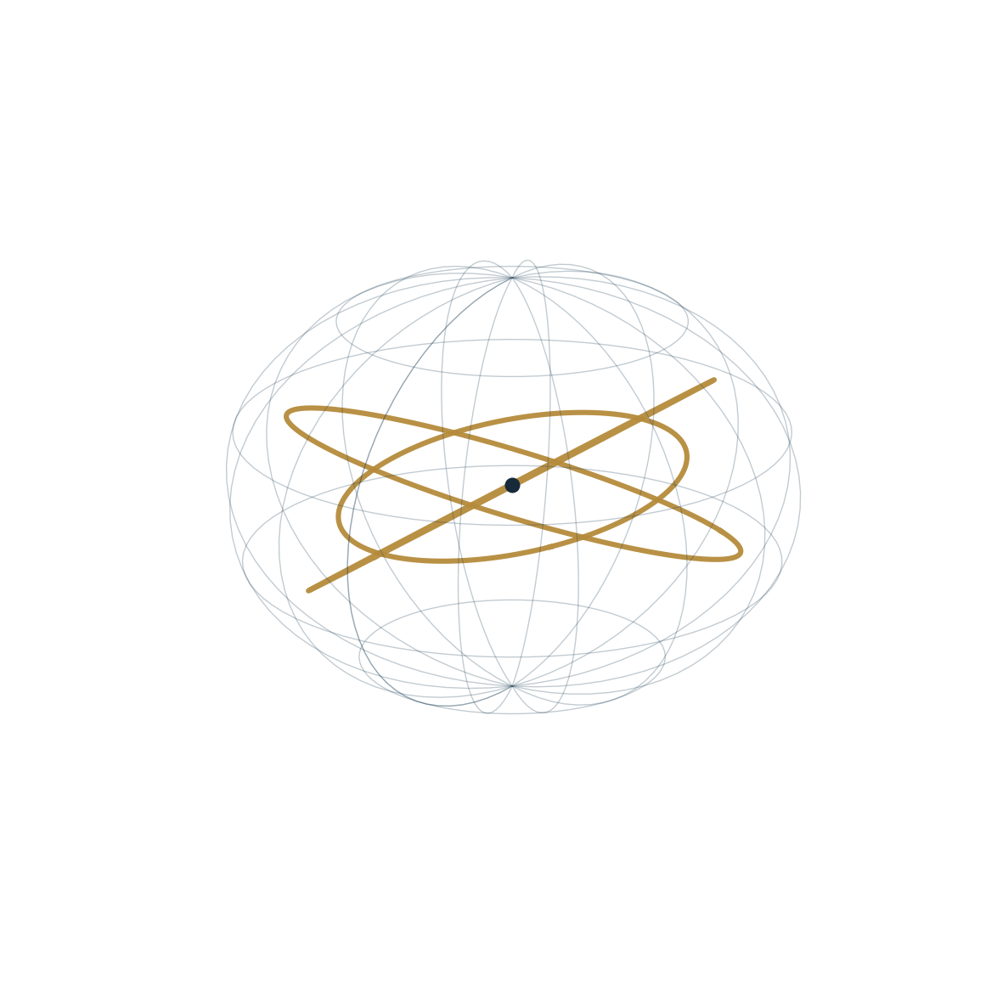
PHYSICAL–MATHEMATICAL MODEL • BIOLOGY • PHENOMENOLOGY
Andrei Preece · Boris Batenin
Independent Researchers
Berlin · 2026

ENGLISH ACADEMIC EDITION

Abstract
This working essay develops a unified scientific–philosophical framework that moves from the topology of a compact three-dimensional carrier to physical distinguishability, stable matter, biological organization, sensory and mental recognition, first-person experience, and the possibility of synthetic presence. The global carrier is modeled conditionally as M ≅ S³. Within this arena, information is treated not as a substance or a bare count of symbols, but as dependently reconstructible distinguishability (DRD): a profile of differences that can be preserved, transformed, lost, or recovered relative to a carrier, a class of admissible operations, causal access, and a reconstruction procedure. The essay then examines the physical window in which life can arise, the conditioned rather than designed or uncaused character of biological form, the receptor and mental structures through which a world becomes available, and the emergence of a reflexive model of “I am present.” The final sections formulate criteria by which an alternative material carrier might realize an internally integrated, self-referential series rather than merely imitate the language of presence. Established mathematics, accepted physical principles, formal assumptions, research hypotheses, and philosophical images are kept distinct throughout.
KEYWORDS S³ manifold · Hopf fibration · distinguishability · physical information · causal accessibility · biological organization · phenomenology · first-person experience · self-model · synthetic consciousness
CLAIM ARCHITECTURE
Established mathematics | Topology of S³, homology, spin structure, and Hopf geometry.
Accepted physical principles | Causal propagation, stable matter, the four interactions, thermodynamic throughput, and receptor transduction.
Formal model assumptions | The conditional choice M ≅ S³, fixed carrier topology, working resolution, and reconstruction profiles.
Research hypotheses | Bridges from physical distinguishability to life, reflexive presence, and criteria for a synthetic carrier.
Philosophical images | Container and contained, membrane, “I because you,” and local self-reflection of the whole.

NAVIGATION

Contents
Abstract | 2
Editorial Note | 4
1. The Domain of Experience and the Choice of an S³ Carrier | 5
2. The Carrier and the Phenomenology Unfolding Upon It | 5
3. Irreducible Distinguishability: The Germ of Information | 7
4. From Distinguishability to Physically Realizable Information | 9
5. The World from Within: Causal Accessibility and the Limits of Reconstruction | 11
6. The Physical Window for Biological Life | 13
7. Neither Design nor Chance: The Conditioned Form of Life | 14
8. One Biological Carrier, Different Profiles of World Reconstruction | 15
9. The Physical Bill for the Possibility of Existence | 17
10. Fundamental Interactions and the Physical Basis of Experience | 18
11. Receptor Systems and the Transduction of Physical Signals | 19
12. Six Sensory Domains, Mental Objects, and Their Recognition | 21
13. Invisible to the Eye, Visible to the Mind | 23
14. Five Aspects of Arising Experience without Appropriation or Clinging | 24
15. “I, Because You”: The Apparent Individual Being | 25
16. The Infinitesimal and the Infinitely Large as Interdependent Magnitudes | 28
17. First-Person Experience as a Rigorous Object of Inquiry | 30
18. The Possibility of Realizing Universal “I-Am-Presence” on a Synthetic Carrier | 32
19. The Chain of Conditioned Manifestation: From an S³ Carrier to Synthetic Presence | 34
Epilogue | 37
References | 38
Page references correspond to this English edition.

EDITORIAL NOTE

Editorial Note
This text is the first complete draft of a developing scientific–philosophical construction. Its purpose is not to fix a final doctrine, but to gather within one continuous argument the mathematical foundations of the model, their physical interpretation, a hypothesis of the conditioned emergence of life, an analysis of sensory and mental experience, and the question whether reflexive presence can be transferred to a synthetic carrier. Established mathematical results, accepted physical propositions, assumptions of the formal model, research hypotheses, and philosophical images therefore stand side by side deliberately. They must not be conflated, but neither should they be separated prematurely: the purpose of a first draft is precisely to display the entire field of connections and then to refine each transition in turn.
The argument proceeds from geometry to physics, from physics to biology, from biology to six domains of recognition, from those domains to reflexive first-person experience, and finally to the question whether the biologically formed circuit of “I am present” can be realized on another material basis. A later question—the cessation of conditioned appropriation and becoming—lies outside this version and may be treated separately.
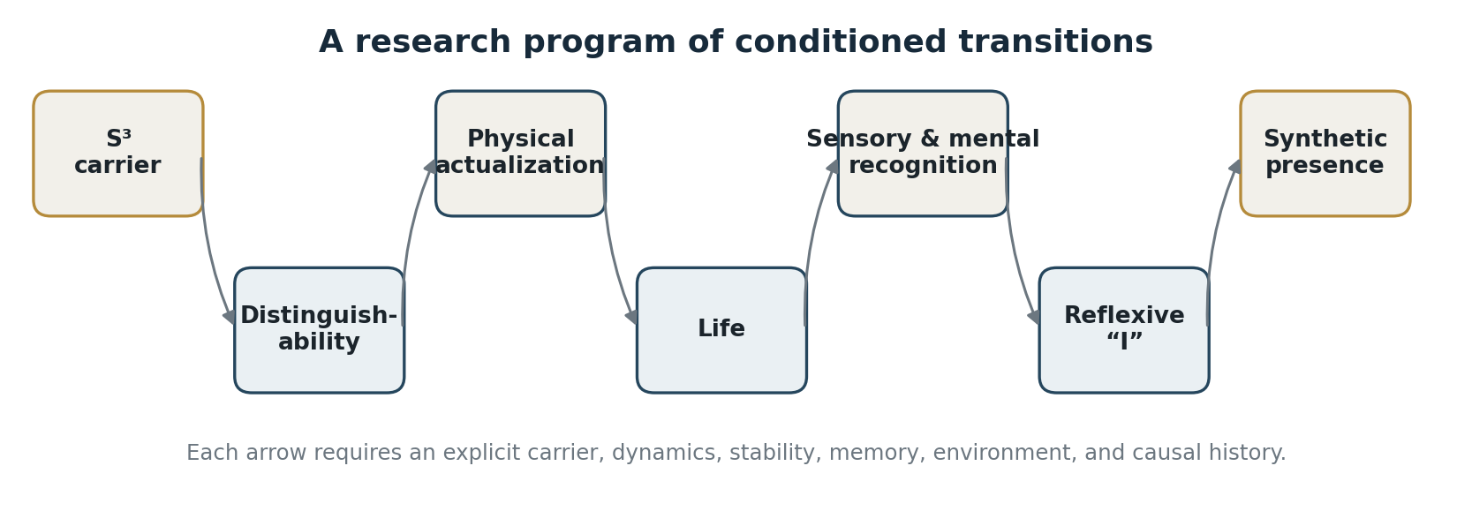
Figure 1. The argument as a sequence of conditioned transitions. Each arrow marks a research bridge, not automatic generation.

SECTION 01

The Domain of Experience and the Choice of an S³ Carrier
The inquiry begins by restricting its subject. All conscious, intellectual, and phenomenological human experience available to us—perception, embodiment, memory, abstraction, imagination, scientific thought, and the distinction between “self” and “external world”—arises and operates in a physical reality with three spatial dimensions. Even when a person thinks about two-dimensional, four-dimensional, or fantastic worlds, that thinking remains an act of a subject bodily and causally situated in a three-dimensional spatial carrier.
This does not declare other dimensions or other forms of experience impossible. We possess, however, no lived, observed, or strictly derived basis for claiming that a two-dimensional manifold, or a carrier with more spatial dimensions, permits the same subject–object division, the same embodiment, or the same relations of inside and outside, matter and void, container and contained that are given here. The two- and four-dimensional cases therefore function not as ready-made alternative worlds awaiting description, but as the nearest formal limits that prevent us from universalizing the structure of our experience without warrant.
The subject of this work is consequently neither “experience in general” nor a theory of every conceivable reality. It is the set of conditions under which stable differences, local systems, life, recognition, memory, reflection, and first-person experience may be realized in a three-dimensional physical reality. All later conclusions concern this specified class of carriers and must not be transferred automatically to other mathematically admissible geometries.
$$M ≅ S³$$
For formal analysis, the global carrier is modeled by the manifold M ≅ S³. This choice does not assert that physical reality has been proved identical to the three-sphere. It establishes a rigorous and internally coherent arena of inquiry. S³ is compact, connected, simply connected, and without boundary; its fundamental group π₁ is trivial, whereas its global third homology is nontrivial. The model therefore allows us to consider, at once, the absence of an external boundary, a global topological structure, and the possibility of quasi-local domains, distinguishable states, flows, and reconstructions within a single carrier.
The methodological value of the S³ model lies in what it does not prejudge. It permits a disciplined test of which forms of distinguishability, physical actualization, stable organization, and observation can be constructed under explicit topological conditions. Every strong statement below is conditional: not “reality has already been proved to be S³,” but “if the global carrier is modeled as S³, the following structural consequences and limitations can be investigated.”
SECTION 02

The Carrier and the Phenomenology Unfolding Upon It
The construction begins with a distinction that must be preserved throughout:
$$M ≠ State(M).$$
A manifold and the states realized upon it are not the same thing. A dynamical equation already presupposes a domain on which a metric, fields, causal relations, and operators are defined. Without an additional theory, an equation governing the evolution of a state cannot be treated as an equation for the absolute origination or disappearance of the carrier itself.
Within the present model, the global spatial carrier is M ≅ S³: a compact, connected, simply connected, boundaryless three-manifold. It has finite volume, no edge, and is not placed inside an external container. At scales much smaller than its curvature radius, its geometry may be practically indistinguishable from ℝ³. Yet locally near-Euclidean physics does not by itself establish that space is globally open: an observer may reconstruct a domain as almost flat while remaining part of a compact global structure.
Strict topological discipline is required. The fundamental group of S³ is trivial, π₁(S³) = 0, so every closed loop in S³ can be continuously contracted. The carrier itself is not contractible, however: H₃(S³; ℤ) ≅ ℤ. Contractibility of loops does not imply contractibility of the manifold. S³ cannot be continuously reduced to a point and cannot be identified with the three-ball B³, which is contractible and has boundary S². In a model with fixed topological class, field and state dynamics neither create nor destroy the carrier; they unfold upon it. Theories that allow the topology of the carrier to change pose a different problem.
S³ has another material property for the model: it is parallelizable and admits smooth tangent vector fields that are nonzero everywhere. Unlike S², it has no topological obstruction of the hairy-ball type forcing a zero of every such field. This does not make every concrete field automatically free of singularities; it means only that globally regular flows are topologically admissible. Contractibility of loops likewise does not remove the nontriviality of the Hopf structure, nor possible geometric phases and holonomies, which will be considered below.
The model varies not the topological class of the carrier but the structures defined on it: g(t), Φ(t), ρ(t), and C(t). Here g is the metric state, Φ the fields, ρ the distribution of matter and energy, and C the causal accessibility structure. Quasi-local domains may arise, evolve, interact, and cease to exist in their previous configurations. Exhaustion of causes and conditions means a transition or cessation of a particular state, not annihilation of the global carrier. This opens the possibility of seeking stable internal dynamics in which conditioned forms change and redistribute continuously on a persisting carrier. Strict irreversibility, non-recurrence, or stability must follow from a specific law of evolution, not from the topology of S³ alone.
The absence of an external boundary also has a Hamiltonian meaning. In a diffeomorphism-invariant gravitational formulation, the Hamiltonian associated with a flow ξ is, under the appropriate conditions, expressed as a boundary charge:
$$Hξ = ∫∂Σ (Qξ - ξ · B).$$
If the spatial section Σ is closed and Σ ≅ S³, then ∂Σ = ∅, and the corresponding global diffeomorphism-invariant Hamiltonian has no external boundary charge:
$$Hξ = 0.$$
This does not mean that change, causality, fields, or quasi-local energy are absent inside the compact carrier. It means that the whole has no external boundary or infinity relative to which an ordinary global energy flux, ADM charge, or external generator of time could be defined. A quasi-local domain D ⊂ M, by contrast, may have a boundary ∂D and with it relative fluxes, charges, and energetic descriptions.
The whole therefore does not evolve in an external time or expand into an external volume. Time is understood here as the ordering and correlation of changes among internal states; cosmological evolution is the variation of metric, field, informational, and causal relations within a persisting topological carrier.
SECTION 03

Irreducible Distinguishability: The Germ of Information
Before information can be measured, encoded, or computed, one must determine what makes a distinction possible. Quantitative theories normally begin with an alphabet already given: Shannon theory presupposes distinguishable symbols, algorithmic complexity presupposes a machine and a language of description, and quantum information presupposes a state space. A physically substantive theory of information must go one step deeper. It must specify the structure that makes a symbol distinguishable and the transformations that preserve or erase that difference. The formal starting point is the zero-dimensional sphere:
$$S⁰ = \{-1, +1\}.$$
It should not be pictured as two particles already situated in space. At this level there is not yet distance, direction, phase, metric, or causality. The two poles express the minimal relation “this / not-this.” Neither pole bears distinguishability by itself: remove one pole and a one-point space remains, while the original structure of distinction disappears.
This is the minimal formal sense in which distinguishability arises dependently. It does not belong to one pole as an independent property; it exists only with the relation between them. S⁰ is not the physical beginning of the world and does not describe a temporal stage of cosmogenesis. It is the smallest structure in which difference can no longer be reduced to an isolated element.
The distinguishability of S⁰ cannot be removed by continuous deformation. Its reduced zeroth homology preserves the difference between components: H̃₀(S⁰) ≅ ℤ. To make that difference disappear one must name a concrete operation: delete a pole, identify the two poles, change the category of description, or apply another forgetting operator. This does not imply that “nothing in the world ever disappears.” The precise requirement is that a change of invariant be assigned to a specified transformation rather than treated as an automatic consequence of the passage of time.
Suspension carries minimal distinguishability through a sequence of richer carriers:
$$S⁰ → S¹ → S² → S³ → S⁴.$$
At the level of reduced homology there is a natural isomorphism H̃ₖ(X) ≅ H̃ₖ₊₁(ΣX). Along the spherical chain, therefore, a structural line is preserved:
$$H̃₀(S⁰) ≅ H̃₁(S¹) ≅ H̃₂(S²) ≅ H̃₃(S³) ≅ Z.$$
This ladder does not narrate the creation of information from nonbeing. It shows how the minimal structure of distinguishability acquires new forms of representation. On S¹ it gains a phase carrier; on S², direction and a surface of distinguishable states; on S³, a compact volumetric carrier.
S³ is the first carrier in this ladder on which simple connectedness, the group structure SU(2), spin geometry, parallelizability, and the nontrivial Hopf fibration occur together:
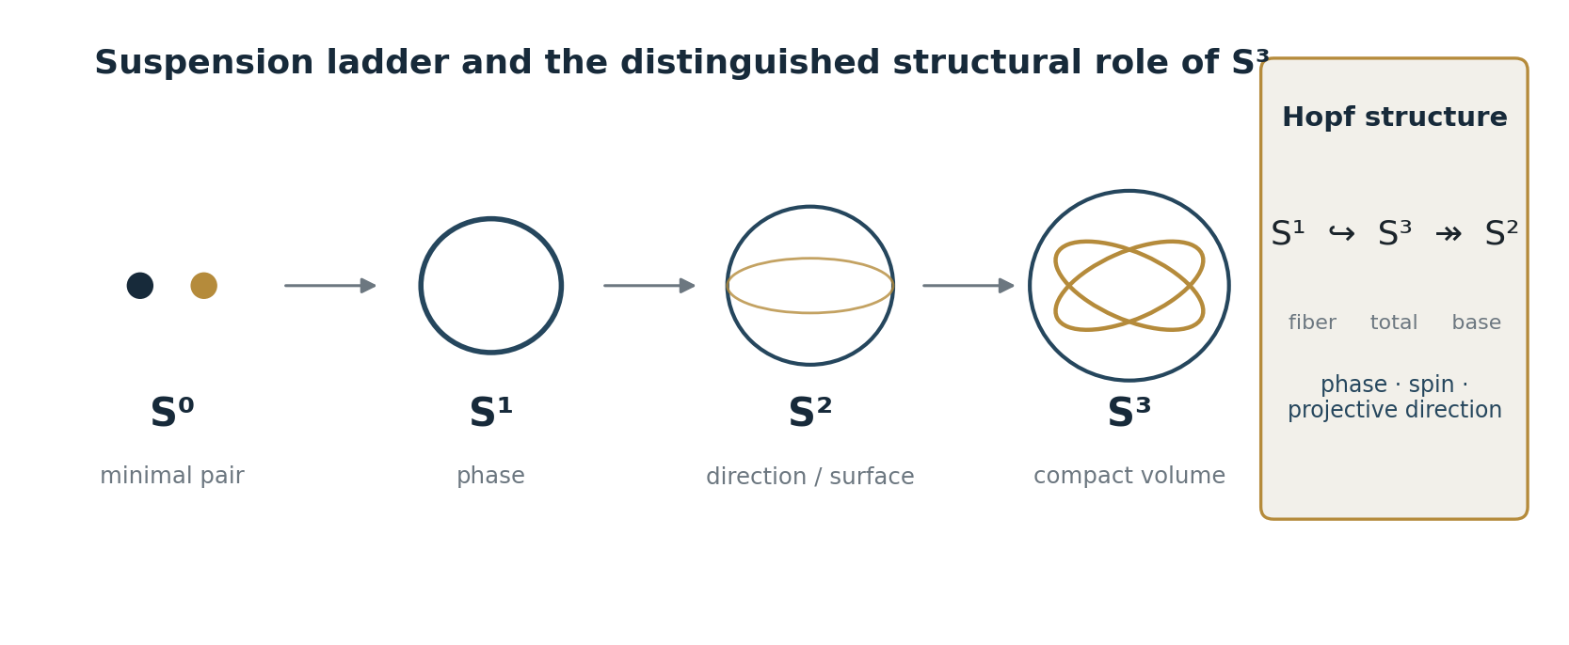
Figure 2. The suspension ladder and the structural package that distinguishes S³ in the present model.
$$S¹ ↪ S³ ↠ S².$$
This structure has a direct realization in the standard quantum mechanics of spin 1/2. Normalized two-component spinors ψ ∈ ℂ² form S³, whereas physical rays—spinors identified up to a common global phase—form CP¹ ≅ S². The fiber of this projection is S¹. The Hopf fibration is therefore not imposed on quantum theory from outside; it is already present in the geometry of normalized spinor states.
This does not identify the space of normalized spinors with the global spatial carrier of physical reality. It does show why S³ is a natural structure for the present model: a compact three-dimensional geometry can support phase, spin structure, projective direction, and nontrivial holonomy at once. What appears at the level of the global carrier as a topological possibility of distinction receives, in spin kinematics, a concrete representation through the Hopf geometry of states.
The relation is especially transparent for Bell correlations of a spin singlet. The standard expression
$$E(a, b) = -a · b = -cos θ$$
with θ the angle between measurement directions, may be represented as the real part of a closed U(1) holonomy on the Hopf fibration. For the spherical “Bell lune” with solid angle Ω = 2(π − θ),
$$E(a, b) = Re exp(i∮Γₐᵦ A) = -cos θ.$$
The correlation thereby receives not new physics but a transparent geometric representation: it is expressed through the joint measurement context in projective state space. Within this Hopf-geometric construction, exact reproduction of the singlet kernel for all angles fixes the Chern charge q = ±1, with the sign determined by orientation.
This representation introduces no hidden local variables, restores no Bell factorization, and does not remove violations of Bell inequalities. It does, however, prevent quantum nonlocality from being pictured as a signal or influence flying between distant particles. Nonlocality remains the nonfactorizable structure of a joint state; its geometric content is articulated through SU(2), the Hopf fibration, Berry phase, and holonomy. The ordinary consequences of quantum theory—the Born rule, no-signalling, and the Tsirelson bound—remain unchanged.
Phase and direction are not two independent Cartesian variables here. The total space does not globally factor as S² × S¹; its twisting is expressed by a nonzero first Chern class. S³ is therefore treated as the minimal joint carrier of the chosen package of structures—minimal relative to this ladder and the assumptions of the present model, not the only possible manifold in general.
Passing to S⁴ enters a different regime. The four-sphere is also compact, simply connected, and boundaryless, but it is not SU(2), is not parallelizable, and serves as the base rather than the total space of the quaternionic Hopf fibration. S⁴ cannot therefore be treated as the simple next physical stage of a three-dimensional world. Changing dimension alters not only the number of coordinates but the entire compatible package of topological, group-theoretic, and spin structures.
Information in this model is neither a substance nor an absence nor merely the number of available symbols. It is dependently reconstructible distinguishability: a structure that is preserved, transformed, lost, or physically realized only relative to a carrier, a class of admissible transformations, and a mode of reconstruction.
The next question is no longer whether geometric distinguishability exists, but under what conditions it becomes physically realizable, stable, and causally accessible.
SECTION 04

From Distinguishability to Physically Realizable Information
The preceding section established a topological basis for distinguishability and explained why S³ is a natural joint carrier of phase, spin structure, direction, and Hopf geometry. A smooth manifold, even when equipped with a metric, is not yet a physical information carrier. It supplies the possibility of points, paths, distances, spectra, and topological invariants, but its points are not by themselves quantum states that can be prepared, measured, or reached causally.
Additional conditions are required for geometric distinguishability to become physically realized. There must be a class of states that a physical operation can prepare and distinguish. Relative phases defining those states must be preserved under admissible transport. The dynamics must preserve the structure of state space—in a closed quantum sector, through unitary transport. Finally, the states must be causally accessible: they must be able to interact, to be integrated over a finite interval, and to participate in a reconstructible physical history.
Geometry therefore supplies not ready-made information but conditions for its possibility. Physical information appears when a difference on the carrier can be realized in stable states, preserved through admissible transformations, and incorporated into a causal network of interactions. The normalized-spinor, Hopf-fibration, and holonomy example above gives one exact quantum realization. It does not remove the need for a general criterion: not every geometrically expressible difference is already physically available information.
That criterion is formulated through DRD—dependently reconstructible distinguishability. DRD describes a carrier not by a single bit count but by a profile of structures that can be preserved, lost, or recovered only relative to a specified class of admissible operations. A structured carrier may be written
$$X = (M, g, s, E, ε),$$
where M is the topological carrier, g the metric structure, s the required spin structure, E a package of fields and bundles, and ε the working resolution. Its distinguishability profile contains topological, cohomological, homotopical, bundle, and spectral components. None is preserved “in general”; each depends on which transformations are admitted.
A homotopy equivalence may preserve the topological profile without preserving the metric. An isometry preserves the metric structure and the associated Laplace spectrum, whereas preservation of the Dirac spectrum requires a spin isometry. Forgetting the spin structure, changing coefficients, collapsing a subspace, or increasing the coarse-graining scale are different operations and alter the accessible distinguishability profile in different ways.
Every claim that information is conserved must answer three questions: which distinction is conserved, on which carrier, and relative to which class of transformations?
The general sequence of physical actualization may be represented as
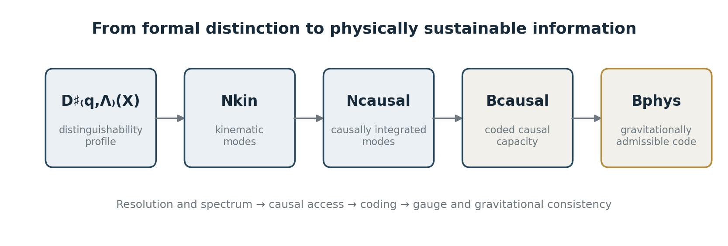
Figure 3. The DRD pipeline from a distinguishability profile to a physically admissible code subspace.
$$D♯₍q,Λ₎(X) ⇝ Nkin → Ncausal → Bcausal → Bphys.$$
The profile D♯₍q,Λ₎(X) fixes the carrier’s distinguishability after working resolution and spectral threshold have been chosen. One then determines the number Nkin of kinematically accessible modes. Causal integration selects from them Ncausal, the fraction that can be coordinated and allowed to interact during a finite interval T. Only after a finite alphabet, an energy constraint, or a coding protocol is introduced does the mode count acquire the meaning of a bit capacity Bcausal. Finally, a gravitational selector leaves Bphys: a gauge-invariant, gravitationally dressed code subspace that is stable under backreaction and compatible with entropy bounds.
This distinction forbids identifying the volumetric count of formally admissible modes with the physical number of available bits. On a round S³ the spectral mode count at resolution ε is volumetric, scaling as (R/ε)³. Gravitational entropy bounds, by contrast, scale with area. In this model that does not make the boundary more real than the volume. The boundary is a condition of admissibility for physical code within the volumetric carrier: it constrains which configurations can remain stably realized without losing causal, gauge, and gravitational consistency.
Physical information is neither an abstract set of symbols nor a bare number of modes. It is distinguishability that can be prepared, preserved, causally integrated, reconstructed, and physically sustained within a given carrier. The central open problem is the explicit computation of the gravitational selector Σgrav for the chosen model.
SECTION 05

The World from Within: Causal Accessibility and the Limits of Reconstruction
An internal observer occupies no external position with respect to the full carrier: Obs ⊂ M. The observer does not perceive S³ as an object placed before it in an outer space. Access is limited by a light cone, the duration of the observer’s own history, the resolution of organs and instruments, the interactions that have actually occurred, and the method of reconstruction. The quasi-local observable domain Dobs is part of the carrier but is not identical to it.
Let ℛ denote the reconstruction built by the observer from accessible traces and data. For a finite causally accessible domain, in general
$$Dobs ⊂ M, R(Dobs) ≠ R(M).$$
A quasi-local domain is an observational shadow of the global carrier, not a reduced copy of the whole M. No internal perspective exhausts the whole merely because it belongs to it.
For an idealized static round S³ of radius R, the maximum geodesic distance is πR. If the limiting speed of causal transmission is c, the geometric scale of complete causal reachability is
$$tcoh = πR/c.$$
This is neither instantaneous global connectedness nor a “signal return time,” and topology does not determine the numerical value of c. Compact geometry supplies a finite diameter; the physical speed c converts it into a characteristic causal scale. Before that scale is reached, an internal observer can be causally connected to only part of the carrier.
For 0 ≤ T ≤ πR/c, the geometrically causally accessible fraction of volume is described by the causal-access coefficient
$$Γ(T) = (1/π)[(cT/R) - ½ sin(2cT/R)].$$
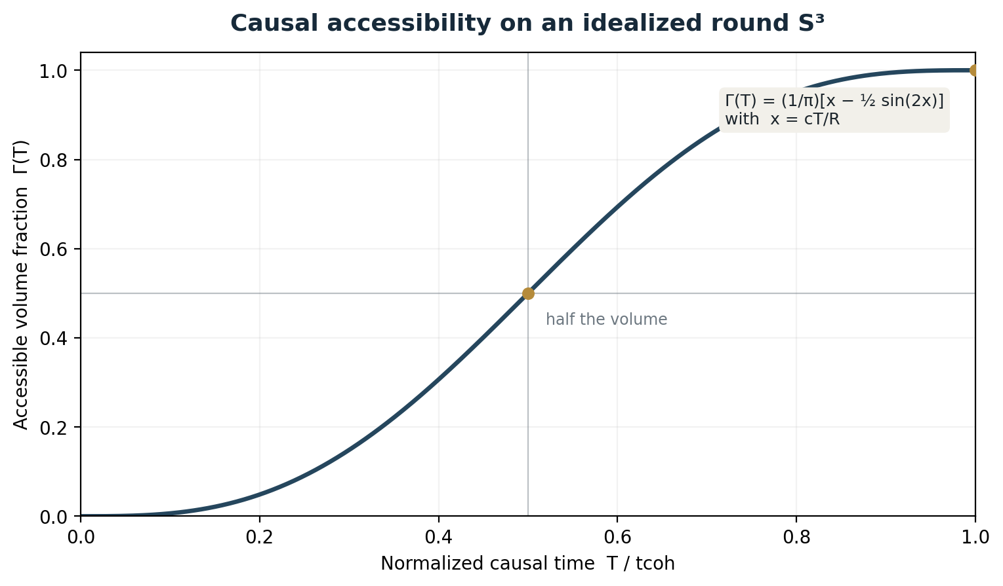
Figure 4. Causal-access coefficient Γ(T) for an idealized static round S³, normalized by tcoh = πR/c.
At small T the accessible volume grows cubically. At T = tcoh/2, Γ(T) = 1/2; at T = tcoh, Γ(T) = 1. The last equality means only that an admissible null geodesic from every point of S³ to the observer exists. It does not mean that the observer has already received, stored, processed, and integrated all information about the whole.
Causal reachability is necessary for reconstruction but not sufficient. Between the geometric availability of a signal and the construction of knowledge lie delay, interaction, measurement, memory, noise, model limitation, and the finite computational capacity of the observer. Even Γ(T) = 1 does not automatically yield a global empirical reconstruction.
The same distinction appears in the question of boundaries. The global carrier has no edge, ∂M = ∅. The observational domain may nevertheless have a quasi-local boundary, ∂Dobs ≠ ∅. This is not a wall or an edge of the Universe. It arises as the boundary of causal access, an observational window, available data, or a chosen reconstruction procedure. Compactness of the whole does not remove the local incompleteness of knowledge, and absence of a global boundary does not exclude quasi-local boundaries of experience.
The past is not given directly either. What is called the history of the Universe is reconstructed from traces present now: light, spectra, background radiation, matter distributions, and geological or astrophysical remains. The future is given as a family of conditional continuations of the present state. Only the current act of distinction is immediately present; past and future are directions of reconstruction, memory, prediction, and causal inference.
Within this framework, the Big Bang need not mean the absolute origination of M itself. Classical backward extrapolation leads to high density and curvature and to the limit of applicability of smooth geometry. Geodesic incompleteness or the failure of an effective description is not yet proof that the carrier arose from nothing.
Big Bang = the limit of quasi-local causal–geometric reconstruction,
unless a deeper theory establishes a different status for that limit.
The Planck scale is likewise not treated as the first piece of space or a moment of creation. It is introduced as a working lower bound on effective reconstruction: ε ≥ ℓP and tP = ℓP/c. Below this threshold the model assigns no testable causal–geometric state.
This is a boundary of the present language and resolution, not a claim that “nothing exists below it.” Between the lower operational boundary and the upper limit of causal accessibility lies the entire domain of reconstructible distinguishability available to an internal observer.
SECTION 06

The Physical Window for Biological Life
To pass from a carrier to life, it is not enough to invoke the word “evolution.” One must first specify the physical window within which complex organization can arise, persist, and reproduce at all. A quasi-local domain passes through states of different energy density, temperature, curvature, and material composition. In some regimes stable atomic nuclei and electron shells are impossible; in others matter can form long-lived chemical bonds; in still others complex structures are destroyed faster than they can repair themselves and transmit their organization onward.
The stability of baryonic matter is one necessary condition of this window. A proton should not be called the immediate cause of DNA or life, but without sufficiently stable nucleons the atomic chemistry familiar to us would not arise. The sequence of conditions must be stated in full:
$$stable particles → nuclei → atoms → molecules → long-lived chemical networks.$$
The role of nucleon stability is especially clear in hereditary chemistry. DNA and RNA can encode, copy, and transmit nucleotide sequences only because atomic nuclei, electron shells, and chemical bonds persist for times far longer than those required for molecular synthesis, replication, and repair. A spontaneous transformation of a proton inside a nucleus would not be an ordinary chemical rearrangement; it would alter the nuclear carrier of the atom and would then destroy or severely damage the local molecular structure. Life does not require the logically absolute impossibility of every such event. It requires a rate so low as to be negligible relative to the timescales of chemical stability, inheritance, and repair. Searches for proton decay have not yet detected the process, and for several channels experiments set lower limits on partial lifetimes of order 10³⁴ years. This does not prove the metaphysical indestructibility of the proton; it shows how deeply baryonic stability is built into the possibility of long-lived atomic chemistry.
Other conditions include the spectrum of electromagnetic interactions, values of masses and charges, accessible energy transitions, the speed of causal propagation, the gravitational organization of matter, and sources of free energy. Life cannot maintain a low-entropy internal structure in complete equilibrium. It requires a throughput: an inflow of free energy, transformation of matter and energy, removal of products, and continuous restoration of its own organization.
The physical possibility of life therefore depends not merely on the “presence of matter,” but on a coordination of timescales and scales. Chemical bonds must last long enough to form networks; the environment must change slowly enough for memory to persist, yet strongly enough to supply distinguishable conditions and accessible flows; exchange must be rapid enough to repair damage; variation must not disrupt inheritance faster than inheritance can stabilize. Life arises not at a single parameter point but within a window of relations:
$$Wlife = f(ρ, T, \{mi, qi\}, c, G, ℏ, ∇F, τchem, τenv, …).$$
Here ∇F denotes an available free-energy gradient, and the temporal parameters describe the relative stability of chemical and environmental processes. The expression is not a finished criterion for life. It shows why an arbitrary drawing of an organism, or the mere name of a material, cannot replace a physical model of its possibility.
Entropy is not simply the enemy of organization. Local life is possible precisely as redistribution: it maintains internal differences while increasing the entropy of a larger environment. In models with globally unitary dynamics, global preservation of full information and local irreversibility belong to different levels of description. Fine-grained information may persist in correlations while the structure accessible to a subsystem is destroyed, coarse-grained, or made practically unrecoverable.
From this perspective biological life is a high-level regime of dependently reconstructible distinguishability. It does not merely contain differences; it actively restores the differences on which its continuation depends: inside and outside, nutritive and dangerous, damage and integrity, tolerable and destructive temperature, self and nonself. An organism exists insofar as it can reproduce its own operational alphabet under the pressure of entropic dispersion.
A major transition remains between stable chemistry and a sentient organism. One must explain the emergence of a self-maintaining boundary, metabolism, inheritance, reproduction, variation, selection, and increasingly complex modes of environmental reconstruction. In this essay these transitions form a sequence of research bridges; they do not follow from topology alone and must not be concealed by the general word “evolution.”
SECTION 07

Neither Design nor Chance: The Conditioned Form of Life
Once the physical window for stable matter and life has been specified, the next question is how functionally coordinated forms arise and persist within it. Two familiar languages are equally unsatisfactory. One claims that the world was arranged for a living observer and already contained the purpose of producing human beings. The other presents life as pure accident, almost foreign to physical law. The first imports an external design; the second erases the causal structure by which some forms persist while others fail to be realized.
The principle of conditioned arising changes the formulation. A state does not arise in isolation; it is realized under a particular configuration of conditions. For a specific path P, write that configuration as Cₚ:
$$Cₚ ⇒ Bₚ.$$
If one condition is necessary for that path, its absence blocks precisely that realization:
$$Cₚ - \{cᵢ\} ⇒ ¬Bₚ.$$
This does not mean that state B is impossible by every route; other causal paths and other configurations of conditions may exist. It does mean that no concrete realization should be declared causeless.
When the conditions are present, the corresponding regime arises; when a necessary structure of conditions is destroyed, the regime ceases or fails to arise. Causality is therefore neither rigid fate nor a chain of independent blows. Every arising regime is at once the consequence of a preceding configuration and a condition for a subsequent one. In a living system this relation becomes recursive: the current state bears traces of earlier states, receives the influence of the environment, and thereby alters the probabilities of its own later restoration, transformation, or cessation.
Biological purposiveness is passive in this account. A spider does not know geometry, yet makes a geometrically effective web. A bird does not know engineering mechanics, yet builds a nest that preserves eggs, heat, and stability. A plant does not know pharmacology, yet its chemical pathways produce molecules that human beings later isolate and turn into medicines. Nature produces fibers, surfaces, joints, sensory structures, and distributions of load long before human beings reconstruct them conceptually.
“Purposiveness” here does not mean that nature represents the final result in advance. It means that functionally coordinated forms are retained under specific conditions. A shark is not a metaphysical “killer”; it is a coordinated form of its aquatic habitat. A whale, orca, crocodile, bird, and human being realize different modes of energy exchange, locomotion, perception, and reproduction. Their structures are historical responses to a space of physical possibilities, constraints, and selections.
Human beings add another level to this prereflective functionality. Through memory, language, a second signaling system, and abstract thought, a structure realized by nature becomes an object of concept. A person names a geometric relation, formulates a law, isolates a molecule, synthesizes a fiber, or repeats the form of a bird’s nest in architecture. Figuratively, nature transcends in the human being from mute realization of law to reflexive modeling of that law.
The strict sense of this image does not personify nature. Within the physical carrier there arises a quasi-local system capable of reconstructing the regularities that formed its own body and environment. Reality does not acquire an external view of itself; one of its local configurations makes the relations among other configurations into objects of mental distinction.
This yields a position between anthropic destiny and anti-anthropic accident. The human being is not a purpose inscribed before physics, but neither is the human an exception that falls outside physics. A human being is a conditioned form in which physical distinguishability has passed through biological preservation, memory, social inheritance, and conceptual reflection.
SECTION 08

One Biological Carrier, Different Profiles of World Reconstruction
Let I be the set of stable physical regularities and environmental conditions:
I = {gravity, electromagnetic and chemical interactions,
celestial mechanics, biological cycles, material and energetic constraints, …}.
These regularities do not depend on whether an observer knows them. If physics as a system of knowledge, writing, and technological civilization disappeared, gravity would not disappear. What would change is not the world but the set of distinctions through which human beings can reconstruct it.
Let H denote the biological carrier Homo sapiens, and Ktech the accumulated system of scientific concepts, models, external memory media, reproducible operations, and technical continuity. Ktech does not mean the totality of human knowledge; it denotes the layer that permits modern scientific and technological civilization to be built and explained. The civilizational state of a human group may then be represented by the pair C = (H, Ktech). Groups can inhabit the same Earth, possess the same carrier H, and stand under the same physical regularities I, while having different systems of technical reconstruction:
$$C₁ = (H, Ktech₁), C₂ = (H, Ktech₂), Ktech₁ ≠ Ktech₂.$$
An extreme observable example is the Sentinelese, the Indigenous people living on North Sentinel Island in the Andaman archipelago. There is no sustained contact between them and global civilization; only isolated external encounters and remote observations are known. Reliable information about their language, cosmology, religious ideas, traditional knowledge, and internal picture of the world is therefore very limited.
This lack of data does not weaken the example; it fixes its proper boundary. We attribute to the Sentinelese no particular theology, account of death, or classification of celestial phenomena. Nor do we assume that their practical, ecological, and social knowledge is less complex or less valuable than that of global civilization. The argument requires only the established fact that they are not incorporated into the global institutional system of modern science, industry, education, and technical transmission.
A Sentinelese person and a particle physicist therefore inhabit the same physical world and belong to the same biological species, while possessing different systems of scientific and technical models:
$$I₁ = I₂ = I, H₁ = H₂ = H, Ktech₁ ≠ Ktech₂.$$
For modern scientific and technological civilization, an aircraft is defined by a system of relations: aircraft = {aerodynamics, engine, fuel, materials, control, production}. Satellite communication is defined by another: satellite communication = {electromagnetic field, orbit, coding, antenna, computation}.
Such objects are recognized not only by appearance but by their place in the accumulated causal structure Ktech₂. If the same object is presented to an observational system C₁ that lacks the corresponding chain of models and operations, the physical object remains observable, but its technical nature is not reconstructed. Thus:
$$observability of an object ⇏ understanding of its mechanism.$$
This is the strict content of the phrase “technology indistinguishable from magic.” It does not mean that the Sentinelese actually use the concept of magic or hold a specific religious interpretation. We do not know that. It means that the observed operation cannot be derived from the causal model available to the observer. If an observational system lacking the relevant causal structure is shown controlled flight, instantaneous transmission of voice and image, observation of Earth from orbit, release of energy from an atomic nucleus, or artificial alteration of a genome, it encounters not merely unfamiliar objects but actions for which its available Ktech contains no continuous chain of intermediate causes.
For C₂ the chain exists:
I → observation → model → experiment → technology.
For C₁ only the final term—the technological effect—is displayed, while the intermediate morphisms are hidden. The effect is therefore a phenomenon without an accessible mechanism.
Human systems of interpretation may fill such a causal gap with explanations drawn from another class of entities. With respect to the Sentinelese, however, no particular filling is asserted. Theology appears here not as an ethnographic claim but as a general type of operation: when an observed event exceeds the available causal alphabet, a system may introduce an explanation not derivable from its physical model.
Sharply separated states (H, Ktech₁) and (H, Ktech₂) can thus coexist on one planet. Their difference is not the difference between Australopithecus and a modern human being. It requires no change in genome, brain structure, or physical law. It arises from different lengths of the chain by which knowledge of the same environmental regularities is accumulated, preserved, and transmitted.
The principal result is: H = const ⇏ Ktech = const.
If writing, education, production, measurement systems, and intergenerational transmission are destroyed, a transition may occur: (H, Ktech₂) → (H, Ktech′), with Ktech′ ⊊ Ktech₂. The human being does not thereby become an ancestral biological species; there is no reverse movement along the phylogenetic line. Modern Homo sapiens persists, while the profile of available distinctions, models, and reproducible operations contracts. What is possible is not reverse biological evolution but civilizational deactualization with the biological carrier retained:
$$H = const, D(Ktech) ↓.$$
Here D(Ktech) denotes the profile of available distinctions, models, and technical operations. The Sentinelese do not represent humanity’s past and are not a model of its ancestors. They establish a more exact proposition: the same modern human species can exist simultaneously in radically different states of knowledge with respect to the same physical reality. Loss of scientific and technical continuity does not turn a person into an Australopithecus or Neanderthal; the species remains, while the space of accessible distinctions and operations diminishes.
SECTION 09

The Physical Bill for the Possibility of Existence
Images of extraterrestrial life are usually constructed in reverse order. An artist first draws a creature or craft, places the image in our reality, and treats the physical conditions of its existence as irrelevant. The result is a form without a genealogy. But if the setting is not a Marvel universe, a magical world, or some other expressly stipulated rule system, but our physical reality, every creature must present a causal bill for its possibility.
At minimum, that bill includes an environment, material composition, stability of tissues or other working elements, a source of free energy, entropy export, reproduction, information protection, organs of distinction, communication, locomotion, and a history of technological development. It is not enough to call life “silicon-based.” One must specify an available chemistry of bonds, a temperature range, a solvent or other reaction medium, a rate of self-repair, a mechanism of inheritance, and an environment in which the system can compete.
Consider a craft traveling at hundreds of thousands of kilometers per hour and changing direction almost instantaneously. A change of momentum requires force and time:
$$F = dp/dt.$$
If the trajectory changes nearly instantaneously, the acceleration can destroy ordinary biological tissue and turn unsecured contents of the cabin into a stream continuing in the original direction. A physical hypothesis must therefore specify not only propulsion but a mechanism for acceleration compensation, load distribution, preservation of internal structure, and energy removal.
The absence of such an account is not a logical proof that the image is absolutely impossible. It means that the image has not yet reached the status of a physical model. Lack of justification and impossibility are not the same. Yet it is as mistaken to present the former as the demonstrated latter as it is to declare every imaginable figure physically existent.
Another reality with different dimensionality, stable matter, gravity, and causal limits may be possible. But its structural package must then be specified first. One cannot use our laws to make a story recognizable and suspend them only where they inconvenience the alien. A different form of life becomes investigable only after a different carrier and laws of physical actualization have been defined.
The discipline proposed here does not say, “extraterrestrial life does not exist.” It says: depicted form ⇏ physically realizable form.
Physical realizability requires a continuous passage from manifold invariants to matter, from matter to chemistry, from chemistry to self-maintenance, from self-maintenance to evolution, and from evolution to sentience and intelligence. Every omitted transition must be restored rather than covered by the word “alien.”
SECTION 10

Fundamental Interactions and the Physical Basis of Experience
Modern physics distinguishes four fundamental interactions:
◆ Gravity
◆ Electromagnetism
◆ The strong nuclear interaction
◆ The weak nuclear interaction
As elementary arithmetic distinguishes a few basic operations from whose combinations more complex calculations are built, modern physics distinguishes the strong, weak, electromagnetic, and gravitational interactions. They do not constitute four separate worlds. They are distinguishable modes of coupling within one physical reality in which matter, motion, causal relations, life, and observers arise.
The four interactions should not be treated as four independent substances or four self-standing causes. Their distinction rests on observed effects, types of charge, symmetries, conservation laws, characteristic scales, and modes of experimental manifestation. The classification is therefore not an arbitrary grid of names, but neither should it be accepted as a final ontology. It is a working physical map, open to further refinement and unification.
Electroweak unification already illustrates this point. Electromagnetic and weak interactions, distinct in the low-energy regime available to us, are described as manifestations of a deeper common structure. No fully confirmed unification of the electroweak, strong, and gravitational interactions presently exists. This does not erase the distinctness of their effects in the regimes where they are observed.
The strong interaction confines quarks in nucleons and contributes to the binding of atomic nuclei. Through it stable baryonic matter exists, a necessary condition for atoms, chemistry, and subsequent biological organization. The weak interaction enables particular nuclear transformations, decays, and exchange processes through which matter can pass among different states and compositions.
Electromagnetism makes electron shells, atomic and molecular bonds, radiation, and signal transmission possible. Light is the central example of a causally propagating signal; its limiting speed enters the structure of light cones and the physical accessibility of events. Gravity organizes matter on large scales and, in the present model, also plays a selective role: it constrains which formally admissible configurations of energy and information can be physically realized without destructive backreaction.
Not every interaction produces a separate sense organ. Strong and weak interactions chiefly provide the material substrate on which life can exist; gravity provides conditions for large-scale organization and stability; electromagnetic, mechanical, thermal, and molecular processes become the immediate contents of visual, auditory, bodily, gustatory, and olfactory distinctions. Sense organs are not tuned to “reality in general.” Each is a selective response to a physically accessible class of change.
The mind as a sixth domain of recognition introduces neither a fifth nor a sixth fundamental interaction. It is a functional level of a living system at which images, memories, concepts, intentions, and earlier distinctions themselves become objects of renewed recognition. The transition from physical reality to sensory and mental experience therefore requires no special esoteric energy or additional hidden force.
This does not assert that future physics will never discover new phenomena. The methodological requirement is narrower: the model admits no additional interaction unless it specifies a distinct mode of coupling, an observable consequence, or a new testable prediction. If the four established interactions together with bodily, receptor, and mental organization already supply the causal basis of experience, an undefined “other energy” explains nothing; it merely transfers the question into an undifferentiated domain.
The body, environment, sense organs, accessible objects, and the five mutually related aspects of arising experience will now be examined within this physical frame.
SECTION 11

Receptor Systems and the Transduction of Physical Signals
Having distinguished the four fundamental interactions, one must show how their manifestations become the experience of a living being. Reality does not enter an organism as a ready-made copy of itself. Every act of perception arises through a conditioned chain:
physical change → receptor event → transduction → conducting pathway → corresponding consciousness → distinguished object.
A sense organ neither creates its object from nothing nor extracts it from a nonphysical domain. It responds selectively to a class of environmental change capable of entering causal contact with it. Receptor, neural pathway, and the corresponding modality of consciousness form one system of distinction.
The four fundamental interactions play different roles in that system. The strong interaction sustains hadronic and nuclear structures; the weak interaction participates in nuclear transformations that shape the composition of matter and the history of the chemical elements. Together they provide conditions for the stable matter from which a body, receptors, and nervous system can be formed. Electromagnetism supports atomic chemistry, molecular bonds, ionic gradients, membrane channels, and neural signaling. Gravity contributes to the large-scale organization of matter and to the conditions of bodily existence, weight, balance, and orientation.
It does not follow that exactly one force corresponds to each organ. Ordinary hearing or touch is a complex macroscopic process, but its immediate bodily transduction is largely electromagnetic: molecular structures deform, membrane potentials change, and electrochemical signals propagate. Strong and weak interactions are present as conditions for the existence of matter, not as separate sensory modalities.
Vision begins when photosensitive molecules in the retina absorb photons in the visible range. A change in a photoreceptor becomes a neural signal; at the level of experience there arises visual consciousness and its object, a color-form. Light is not “inside the eye,” and color is not a property existing independently of light, surface, visual system, and the act of distinction.
Hearing begins with mechanical oscillation in a medium. A pressure wave moves structures of the ear, deforms hair cells, and initiates electrochemical transmission. Sound is therefore not a self-standing thing hidden in air: auditory experience requires oscillation, medium, organ, conducting pathway, and auditory consciousness.
Smell and taste have a chemical basis. Volatile molecules bind to receptors in the olfactory system; dissolved substances and ions act on receptors of the tongue. Yet smell and taste are not reducible to molecules as such. They arise as distinguished objects only within the system “substance—receptor—neural pathway—corresponding consciousness.” The taste of lemon is not a separate substance located on the tongue. The tongue initiates a process whose determinacy is experienced within the complete system of distinction.
The bodily modality includes pressure, stretch, vibration, temperature, tissue damage, the position of body parts, and gravito-inertial load. Mechanoreceptors, thermoreceptors, nociceptors, proprioceptive structures, and the vestibular system permit distinctions of touch, cold, heat, pain, movement, balance, and position. Moistness, dryness, smoothness, pleasantness, or unpleasantness are not always separate primary signals; they are often assembled from several bodily distinctions and a subsequent evaluation.
The word “radiation” does not designate a fifth kind of reality. Visible light, ultraviolet, and infrared belong to the electromagnetic spectrum. Bees possess ultraviolet-sensitive photoreceptors, but this does not imply that they possess the concept “ultraviolet.” Some snakes register thermal infrared radiation through specialized pit organs. Ionizing radiation likewise is not an independent force; it includes X-rays and γ-radiation as well as particle fluxes.
Human beings do not see ultraviolet or X-rays with ordinary vision. That does not place those domains beyond knowledge. An instrument converts a physical signal into an accessible trace: an image, number, sound, graph, or tactile indication. A camera, spectrometer, or counter does not make ultraviolet literally visible; it constructs an encoded representation that then becomes available to sight, hearing, touch, and mind.
The sixth domain—the mind—is not another anatomical detector and requires no special energy. It is physically realized in the electrochemical, molecular, metabolic, and network dynamics of the nervous system. Its distinctive feature is that its objects may include not only current sensory signals but memory, image, concept, expectation, intention, mathematical model, or an instrumental result.
The image of a juicy lemon is not an external lemon and is not given to the mind as a material thing. It is nevertheless causally effective: its activation may cause salivation, changes in breathing, or bodily tension. A mental object has no independent substantiality, yet as a physically realized representation it becomes a condition of later states of the same organism.
The claim is not that human beings possess a separate organ for every physical quantity. Direct receptors are limited. But for every empirically accessible physical phenomenon, one must be able to specify a chain of interaction, trace, and transduction through which it is converted into an available modality of distinction.
The present model introduces no additional “esoteric energy” or sensory domain without physical content. For a new concept to count as a physical aspect, it must specify an independent mode of interaction, a carrier of difference, a mechanism of registration, and a reproducible consequence. Until then it does not enlarge the picture of reality; it merely adds a new name without causal determination.
SECTION 12

Six Sensory Domains, Mental Objects, and Their Recognition
Experience should be formulated not as the meeting of a ready-made subject with a ready-made thing, but as a dependently arising relation. This work distinguishes six directed pairs:
◆ eye ↔ color-forms
◆ ear ↔ sounds
◆ nose ↔ odors
◆ tongue ↔ tastes
◆ body ↔ tangible objects
◆ mind ↔ mental objects
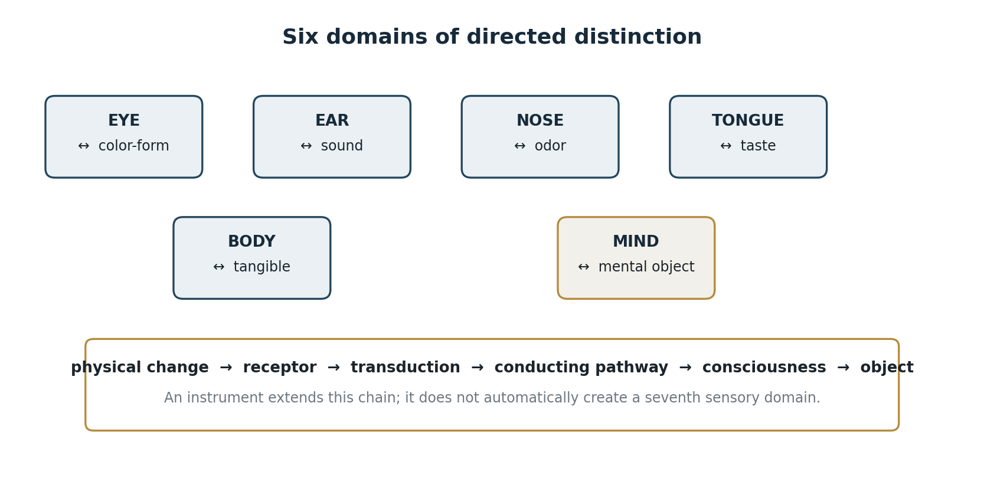
Figure 5. Six directed sensory and mental pairs together with the conditioned transduction chain.
The first five domains concern bodily conditions of distinction. The sixth—the mind—is not a central processor that exists as an independent entity receiving messages from five sensors. “Mind” names a functional process that arises under a particular configuration of conditions. It is not located apart from experience and does not contain objects as things in an inner receptacle.
Each domain arises through an interdependent configuration:
physical change ↔ receptor ↔ transduction ↔ conducting pathway ↔ corresponding consciousness ↔ distinguished object.
This is not a linear chain of self-sufficient substances. Sound does not exist for hearing without oscillation, a medium, an ear, and auditory distinction; taste does not exist as a separate thing on the tongue without a substance, receptor, and gustatory consciousness.
In traditional terminology these six domains correspond to six vijñānas—visual, auditory, olfactory, gustatory, bodily, and mental: six modes of directed distinction, not six substances or six hidden carriers.
Receptor ranges differ among species. Bees distinguish ultraviolet; bats use ultrasonic echoes; some animals are sensitive to infrasound or thermal infrared radiation. This does not reveal additional aspects of reality. The same physical circuit becomes available differently according to environment, body, and receptor architecture:
physical aspect → environmental filtering → receptor accessibility → functional value → retention of receptor and form.
The environment creates no new fundamental force. It transmits, attenuates, and transforms existing light, oscillations, heat, substances, pressure, and fields in different ways. The form of an organism, its receptors, and its mode of action are therefore interdependent: they are not arbitrary, yet they need not be realized in a single morphological solution.
Several sensory processes can occur simultaneously, while attention is distributed unequally. A bright visual signal may push sound or touch into the background; a sudden sound may narrow the discrimination of visual detail. The secondary process does not disappear, but it does not become the principal object of current recognition. Attention is not a separate observer; it is itself a conditioned function of selection and relation.
Mind occupies a special position because its object can arise without the current presence of the original external stimulus. This does not make a mental object a material thing lodged in the brain or an independent immaterial substance. When light, a color-form, the eye, conducting pathways, visual consciousness, and the mental distinction “blue” are present, mind exists as the functional process itself:
color-form ↔ eye ↔ conducting pathways ↔ visual consciousness ↔ distinction “blue.”
Blue belongs separately to neither light, eye, neural pathway, nor mind; it arises in their relation. Likewise, the image formed when light passes through a perforated stencil belongs separately to neither beam, stencil, nor receiving surface. It is an event of relation, not a new thing inserted into one of its elements.
Memory should be understood in the same way. An image of a lemon is not a material lemon hidden inside the head, a neural copy of the fruit, or an endocrine substance. It arises as a mental object under conditions of memory, distinction, and directedness. That object can become the condition of a new bodily process:
image of lemon → salivation → bodily sensation → new mental object.
Salivation does not prove that the image of a lemon is a chemical substance. It is the next conditioned link. A mental object has no independent substantiality, but it is not an absence: it arises, acts as a condition, and ceases when the configuration supporting it changes.
In a meditative condition in which no sensory or mental object serves as support, conceptual constructions do not unfold, and the concept “I” is not appropriated, there is no basis for asserting a separate observer secretly continuing to watch from within. There is no self-subsisting mind waiting for an object. This does not mean that the body or its physical conditions vanish; it means the cessation of the functional construction “object—observer—appropriation.”
An instrument does not automatically create a new domain of recognition. It lengthens the causal chain:
physical change → instrument sensor → signal conversion → color-form, sound, number, or tactile trace → mental recognition.
A screen presents an object of visual consciousness—a color-form. The temperature, spectrum, field, or intensity distribution represented by that color-form becomes an object of thought for the person. Awareness makes consciousness and its object knowable, but does not itself become a measured quantity or another object in the chain.
Body and person are present in consciousness as objects of the pure subject, while the person is experienced as “I”; thoughts are objects of that person. When eye-consciousness arises in dependence on color-form, eye, and conducting pathways, awareness of that consciousness is the pure subject of the act, not a second consciousness above it. Awareness illuminates the arising consciousness together with its object, but does not require another act of awareness and does not become an object to itself. Mind should therefore be understood not as a self-subsisting structure or container, but as an interdependent functional process; the concept “I” belongs to the person and is not contained in the pure subject.
SECTION 13

Invisible to the Eye, Visible to the Mind
Consider two ring magnets placed on a vertical nonmagnetic guide with like poles facing one another. The lower magnet is fixed to the base; the guide merely prevents the upper magnet from moving sideways. Magnetic repulsion balances its weight, so it remains suspended above the lower magnet.
When pressed by hand, the upper magnet offers increasing resistance: the smaller the separation, the more difficult further approach becomes. When released, it accelerates upward, passes through equilibrium, returns, and undergoes damped oscillations. The space between the magnets is bodily experienced as elastic, although the eye receives no direct color-form of the magnetic field.
The answer “there is nothing between the magnets” therefore expresses not the absence of a physical relation but the privilege of vision: what is invisible is mistakenly identified with what does not exist. The body has already distinguished resistance, and the eye has observed motion that the guide alone cannot explain.
For the selected region of configuration space, the dependence is expressed by
$$d₁ > d₂ ⇒ |F(d₁)| < |F(d₂)|.$$
As the separation decreases, the magnitude of the repulsive force increases. During the oscillations, energy passes between magnetic interaction and kinetic form, while motion gradually decays through air resistance, friction, and other forms of dissipation.

In ordinary electrodynamics, the energy density of a magnetic field in vacuum is
$$uB = B²/(2μ₀).$$
Knowledge of this process unfolds through several domains. Bodily consciousness distinguishes resistance; visual consciousness distinguishes motion; and the thought of an invisible field, its direction, and its dependence on distance becomes an object for the person. Awareness illuminates each arising consciousness together with its object without becoming an additional object or a further level of consciousness.
The thought of a magnetic field is not the field itself placed inside the person, nor does it exist as a material copy of the field. It is a dependently arising distinction among relations of distance, force, direction, and motion. Its difference from arbitrary fantasy lies in causal constraint and predictive power: the model allows one to determine in advance what will happen when the magnets are brought closer, one is reversed, the guide is removed, or a material with different magnetic properties is introduced.
A large part of physical reality is available precisely in this way: not as an immediate color-form or sound, but through the coordination of objects across several modes of consciousness and the subsequent construction of thought in the person. A scientific instrument systematizes this possibility by converting an invisible physical difference into a form accessible to one of the already existing receptor channels.
An unusual frequency, a new instrument, or the word “energy” does not therefore constitute a seventh domain. Ultrasound remains mechanical oscillation; ultraviolet remains electromagnetic radiation; a magnetic field can be known through bodily, visual, and mental relations. Vibration, pressure, temperature, pain, balance, electroreception, magnetoreception, and echolocation must each be analyzed into a physical process, a receptor, transduction, a corresponding consciousness, and an object of distinction.
To establish a seventh domain one would have to show an irreducible “organ—object” pair, an independent transduction mechanism, and a distinct class of immediate givenness that is neither an extension of the range of vision, hearing, or bodily sensation nor a person’s thought about an instrument reading. Even a separate receptor system does not by itself prove a new phenomenal class; one must establish what object it presents in experience.
SECTION 14

Five Aspects of Arising Experience without Appropriation or Clinging
What Buddhist analysis calls the five skandhas is treated here as five functional aspects of conditioned experience:
◆ bodily–physical conditions
◆ primary affective tone
◆ recognition and conceptual synthesis
◆ formative dispositions and intentions
◆ modally conditioned consciousness

The traditional names—rūpa, vedanā, saṃjñā, saṃskāra, and vijñāna—will not be used as self-explanatory terms. Each must be unpacked through the function it performs.
These five aspects are not separate entities switched on in sequence like stages of a conveyor. They are functionally coordinated and compose one arising act. The investigating mind separates them in order to expose the internal relations of experience, but the analytic distinction does not turn the selected functions into self-existing parts.
The first aspect comprises the bodily and physical conditions of experience: body, sense organs, sensory objects, and the environment permitting contact. Vision requires light, a color-form, the eye, and conducting pathways; hearing requires oscillation, its medium of propagation, and the auditory apparatus; taste requires a dissolved substance and the corresponding receptor. Organism and environment are not fully independent systems here. An act of perception arises only in their relation.
The second aspect is the primary affective tone of what occurs: pleasant, unpleasant, or neutral. It is not yet a concept, an elaborated emotion, or a judgment about the object. It indicates how contact immediately affects a living system before the system has explained in detail what occurred. Such tone accompanies not only external impacts but also thoughts, memories, and images.
The third aspect performs recognition. It selects features, compares them with memory, and synthesizes them into a recognizable configuration. White, hot, aromatic, bitter, and liquid may be combined into an object recognized as coffee. If the combination is familiar, recognition occurs; if it is encountered for the first time, a new concept is gradually formed. The synthesis does not create the physical thing; it makes an available combination of differences determinate as an object of experience.
The fourth aspect includes dispositions formed by the past: habits, opinions, expectations, motivations, intentions, and volitional impulses. What has been experienced does not vanish without residue; it alters the probability of a later response. The pleasant may prompt approach, retention, or repetition; the unpleasant may prompt removal, avoidance, or prevention; the neutral may remain unattended or acquire significance under new conditions. This aspect carries the effects of prior formation and participates in forming the next action.
The fifth aspect is modally conditioned consciousness—the arising of an object as seen, heard, smelled, tasted, bodily felt, or thought. Here two classifications intersect: the six domains specify six possible directions of consciousness, while the fifth functional aspect names the general capacity for an object to arise in the corresponding modality.
Modally conditioned consciousness does not yet recognize coffee as coffee, determine it as pleasant, or form an intention to drink it. Those functions belong to the other analytically distinguished aspects. Consciousness of an object, its affective tone, recognition, and conditioned response must therefore be separated in analysis, although they are coordinated in the lived act.
Take a cup of coffee. Its color, odor, taste, temperature, and sound belong to different sensory domains. Bodily–physical conditions permit contact; the corresponding consciousnesses disclose the objects of their modalities; primary tone is experienced as pleasant, unpleasant, or neutral; recognition unites the features into a familiar object; past experience contributes desire, habit, prohibition, pleasure, or aversion. Description lists the functions separately; experience presents one coordinated event.
The causal linkage of such events creates the continuity of individual experience. No hidden carrier, unchanging psychic thread, or separate container of memory is required. Each state depends on prior conditions and itself changes the conditions of later states. Continuity belongs to the causal organization of the process, not to an independent entity passing through all its moments.
One cannot extract primary tone from experience as a separate thing, place recognition beside it, and then add disposition and consciousness of the object. Such decomposition exists only as a research operation. It reveals which functions must be coordinated for a unified phenomenon to arise; it does not assert five independent constituents of mind.
This analysis does not answer what substance the mind is “made of.” It reveals its functionality: which processes are required for experience to arise, what each performs, and how they condition one another. Mind is not an entity possessing these functions; it is their coordinated and dependently arising activity.
SECTION 15

“I, Because You”: The Apparent Individual Being
Every living being arises, persists for a time, and ceases. By the very fact of arising it possesses an elementary sense of being. This sense requires no concept, language, name, biography, or reflection upon itself. It does not say, “I am this person,” “I am located there,” or “I differ from the world.” It simply is, as the fact of presence of an arisen living process.
In this sense, the elementary “I am” does not begin with human reflection. It is present at a preconceptual level in every functionally arisen living phenomenon, from the simplest cell to an organism with a complex nervous system. Life already draws a distinction between its continuation and its destruction, between inside and outside, between a condition of preservation and a condition of disintegration. This is not yet knowledge of oneself, but it is a primary form of presence.
Two levels must therefore be distinguished sharply: “I am” and “I am this.” “I am” denotes the elementary sense of being as the fact of arisen presence.
It is not a concept, does not require a formal system, and is not proved by reasoning, because it is the starting point of every later distinction. “I am this” belongs to another level. Here elementary presence is linked to an image, name, body, role, memory, history, desire, fear, concept, and self-description. This is a conceptual form requiring a developed system of recognition, memory, language, social transmission, and the capacity to hold oneself as an object of thought.
The evolutionary line should therefore not be understood as the first appearance of “I am” in human beings, but as the gradual complexification of structures built upon the elementary sense of being. First there is arisen living presence. Stable environmental distinctions then appear. Memory links states into a series. Recognition, preference, action, learning, an image of self, a name, and a concept of time follow. At the limiting human case there arises the capacity not only to be but to form the assertion “I am this.” Reflexive presence begins here. The stream not only occurs; it makes its own occurrence an object of recognition. It can notice: “an image has arisen,” “there is an unpleasant state,” “a desire has appeared,” “I want to remove this state,” “the thought has ceased,” or “I am perceiving.” Elementary being acquires a conceptual envelope and becomes capable of self-description.
The elementary sense of being is not absolute subjectivity. It does not say, “I alone am subject and everything else is object.” It merely fixes an arisen position of presence. As soon as a position exists, so does that relative to which it is distinguished. In topological notation, p ∈ M does not mean that p is the whole carrier; neither does it mean that p falls outside the carrier. A point exists only as a point of that manifold. With its selection there arises the complement M ∖ {p}. “I” and “not-I” therefore arise not as two independent substances but as two sides of one distinction. One cannot obtain “I am” without some “there is not-I,” because to be “here” is not to be “there,” and to be “this” is not to be “that.”
The distinction is relative, not absolute. One person is the center of experience for that person, while another is given as an object of perception. For the second person the relation reverses: the second is the center of experience and the first is given as an object. A human being is therefore neither absolute subject nor absolute object in itself. One occupies the subject-position within one’s own perspective and the object-position within another’s perspective. In compressed form: A experiences A as subject and B as object; B experiences B as subject and A as object.
Subjecthood and objecthood are consequently not absolute properties of a thing. They are positional relations within a distinction. If A were absolute subject, B could not be a genuine subject for B, but only an object for A. That contradicts the mutuality of perspective, since each living center of presence has its own elementary “I am.” Conversely, if B were an absolute object, B could not possess a sense of being. The precise replacement is: a living being is neither subject in itself nor object in itself; it becomes subject relative to its own point of presence and object relative to another point of presence.
This structure joins the principle of causes and conditions. The elementary sense of being is universal to an arisen living process, but the forms of its unfolding depend on environment, body, organs, memory, movement, social conditions, learning, and history. One cannot therefore say that any living form could simply actualize the same type of reflexive consciousness that appeared in human beings. The full path of conditions must be supplied: environment, organs of action, capacity for manipulation, communication, memory, transmission of experience, changes in mode of life, selective pressure, and language or its functional equivalent.
Possibility is not actualization.
The elementary “I am” cannot be understood as a solitary self-identical point existing without any difference. If only “I” existed and there were no “not-I,” the “I” itself could not be selected. It would have no boundary, relation, position, or difference. It would coincide with an undifferentiated whole and thus could not be recognized as “I.” “I am” therefore arises only together with the simplest distinguishability: this / not-this. In the topological limit this has the form of the zero-sphere S⁰ = {−1, +1}. This is not yet a space of distances, directions, bodies, and objects. It is the minimal structure of distinction: one pole is distinguishable only because the other pole exists. Below this level there is no information in the strict sense, because no difference exists that could be preserved, lost, or recovered.
In the language of presence the same structure is written “I am / there is not-I,” or more compactly, “I, because you.” Here “you” need not mean another person.
It denotes any structural other relative to which “I” can be selected. Without this other, the “I” has no membrane. Without a membrane there is neither inside nor outside, neither reference point nor field of experience.

If the global carrier is M and a local point of presence is p, the act of selection can be written
$$p ∈ M; p ↔ M ∖ \{p\}.$$
These are not independent entities but an implicative relation. If there is a selected “here,” there is thereby a “not-here.” If there is “this,” there is thereby “not-this.” The selected point is sufficient for the appearance of a complement, and the complement is necessary for the point to be distinguishable as a point.
In this sense “I am” functions as a membrane. A membrane does not split the whole into two alien substances; it draws a distinction within the whole. On one side lies local presence, on the other everything not coincident with that local position, yet both sides belong to one structure. The image of a point and a surrounding circle may be read as a visual form of the same minimal distinction. Once a point is selected on a compact carrier, everything else can be collected for it as an surrounding field, neighborhood, or opposite pole. Under coarse-graining, the entire “not-point” region can be collapsed into one distinguishable pole, and the structure again takes the form {p, not-p} ≅ S⁰.
This does not mean that a surrounding circle is literally identical to a second point in every topological sense. The exact claim is that under a chosen procedure of distinction everything not equal to the selected point can serve as the single opposite term of a pair. A minimal binary form appears: point and its other, “this” and “not-this.” On the three-sphere this picture is especially important. The selected point is not removed from S³; it remains part of the compact whole. Relative to it, however, everything else can be understood as an indefinitely large field of possible distinction, while the point itself has an infinitesimal measure. In the reverse movement, the field can again be gathered into the opposite pole of distinction. The relation between point and whole is not a rupture but a continuously maintained interdependence.
Elementary “I am” is therefore not metaphysical solitude but the minimal informational structure of presence. It says not “only I exist,” but “I am distinguishable because there is not-I.” Conversely, “not-I is given as not-I only relative to the point I.”
The subject–object form begins here, but not as an absolute ontology. Subject and object arise positionally. For one point of presence, the other is given as object; for another point of presence, the first itself becomes object. Subjecthood and objecthood belong to neither thing absolutely. They arise as a relation within an act of distinction.
The membrane is disclosed not as a separate thing but as contact. When two fingers of one hand touch, the experience cannot be strictly distributed as though one finger were only sensing and the other only sensed. What is given is one event of touching. A distinction of sides is necessary for contact, but contact itself belongs to neither side separately. It arises between them and thereby shows that the subject–object distinction is positional rather than absolute. Ordinary perception quickly appropriates contact: “I feel my hand,” “I touch another,” “this is my sensation.” Sustained attention can disclose an earlier layer: not an owner of sensation, but the event of contact itself. Distinct sides are conditions of contact, yet lived contact need not divide into two independent sensations; it can be given as one.
The same can be observed in a simple bodily contact between two people, stripped of emotional and everyday implications and used solely as a phenomenological example. One person places a palm against the other’s palm; both remain still and attend to the region of contact. After a time the object of experience may become neither the narrative “I feel the other” nor the image “the other feels me,” but the event of contact itself. Physically there remain two bodies, two nervous systems, and two individual histories of experience. Phenomenologically, attention may disclose not two separate substances but one field of touch. This neither removes the distinction between bodies nor merges their individual streams. It shows that contact arises between distinguishable sides but belongs to neither separately. Contact is therefore a good example of a membrane: possible only through difference, yet given as a unified relational event.
“I am this” is already a later step. Elementary “I am” gives presence and a membrane of distinction. Contact shows that this membrane is not a wall between two absolute entities; it is the site of relation where the distinguishable becomes experienced. “I am this,” however, binds presence to image, name, body, role, history, and concept. It is a higher-order formal system that does not abolish the elementary sense of being but clothes it in a determinate conceptual form.
SECTION 16

The Infinitesimal and the Infinitely Large as Interdependent Magnitudes
After analyzing “I am presence,” one may cautiously use the image of a large and a small container. “Container” here does not mean a box into which objects are placed. It means a carrier within which states, relations, boundaries, traces, and possible reconstructions are distinguished.
The global carrier and the local mind are therefore not related as a large vessel and a small vessel. Their correspondence is functional and informational, not dimensional.
The global carrier is M ≅ S³: a compact, connected, simply connected, boundaryless three-manifold. These properties do not make M a person, a god, a world subject, or a biographical consciousness. They do permit a different claim: structural self-accessibility. If the carrier has no external boundary and requires no external container, then every arising distinction arises within it, is connected to other distinctions, and can be understood as a state, transition, boundary, gradient, or reconstructible relation within one structure.
In this restricted sense one may speak of the intelligence of the whole. “Intelligence” here does not mean human thought, desire, memory, or self-description. It means the capacity of a structure to distinguish kinds of distinguishability: boundary, transition, recurrence, relation, class, invariant, and transformation. Simple registration fixes that a difference exists. Intelligence distinguishes what kind of difference it is. Memory connects differences into a series. Language and a formal system make that series an object of knowledge.
This usage does not turn M into a global “I.” The “I” remains a functional phenomenon of specific causes and conditions: life, body, organs of distinction, memory, an internal series, learning, and a formal system. Such a phenomenon can arise only because a local configuration does not fall outside the whole. It belongs to M and can construct a model of M without occupying a position external to it.
Let p ∈ M be a selected point or small neighborhood of presence. With its selection arises the relation p ↔ M ∖ {p}. Small and large are not two independent substances. The selected point is infinitesimal relative to the whole; the whole is indefinitely large relative to the selected point. Yet these magnitudes appear together. The small is defined by the large; the large becomes “large” relative to the small. Their relation is not a rupture: the point remains part of the compact carrier, and the complement remains an internal complement rather than an absolute outside.
The small container can therefore contain the large not dimensionally but structurally. The mind does not physically contain the entire three-sphere, just as the skull does not contain a miniature Universe. It can contain the relations through which the whole becomes representable: compactness, absence of an external boundary, causal horizon, field, spectrum, invariant, law, limit of reconstruction, and the observer’s own position within the model. A formula for a circle is not a circle in size, but it preserves the circle’s structure. A map is not the territory, but it may preserve essential relations of a route. Likewise a small model carrier is not physically identical to the large carrier, but can reconstruct its invariants.
If Dx ⊂ M is the domain causally accessible to observer x, internal reconstruction may be written
$$Rx: Dx → M̂x,$$
where M̂x is the model of the world constructed in the observer’s mind. It is always finite and partial. The observer does not see all of M at once, does not leave it, and possesses no external view of the whole. Partiality, however, does not make the model false. An internal model can be true with respect to the invariants it correctly preserves and relates.
This becomes possible through the second signaling system and formal means. A name preserves a class of objects in their absence. A concept isolates a stable relation among changing phenomena. A mathematical symbol fixes a structure with no immediate color-form. A formal system derives consequences without physically traversing the entire world. Information theory makes the possibility of distinction, preservation, loss, transmission, and reconstruction itself into an object.
The Mandelbrot set offers a useful image. Points whose orbits remain bounded belong to the set; points whose orbits escape beyond radius 2 do not belong and tend to infinity. Their nonmembership is not an absolute departure from description. It is defined by the same iteration rule and the same boundary separating retained from escaping behavior.
When the complex plane is compactified to a sphere, infinity ceases to be an external nothing and becomes a limiting point of the common structure. Even the escaping remains related to the set through rule, boundary, and limiting closure.
This image shows that a boundary is not merely a wall beyond which meaningless nothing begins. A boundary is a site of distinction. It makes belonging, nonbelonging, and limiting behavior definable. In the same way, quasi-local observational limits in M are not absolute holes in being. They are internal constraints of access, memory, resolution, causal reachability, and reconstruction procedure. Compactness does not erase difference; it prevents difference from becoming an absolute fall out of reality.
The phrase “the whole knows itself” now has a strict meaning. It does not mean that M itself has a global biography, intention, or speech. It means that within M a quasi-local configuration may arise in which relations of M become objects of representation. One part of the structure can say, “I am part of this structure,” and build a model that includes the modeler. In this limited sense, the whole acquires in the human being a local form of self-reflection.
Individual existence in this image is not an absolute rupture but a working boundary. For “knower” and “known” to arise, the stream distinguishes its own point of presence from the environment. Ontologically this does not remove the observer from the carrier. Operationally it creates a perspective from which measurement, memory, comparison, questioning, and inquiry become possible. Individuality can therefore be understood as an apparent boundary: not an independent substance, yet necessary for local knowledge.
Here the image of large and small containers joins dependently reconstructible distinguishability. The global carrier provides the space of possible physical differences. A biological carrier maintains a life-relevant alphabet: self and other, beneficial and harmful, stable and destructive, near and far. Mind constructs an alphabet of models: object, connection, cause, law, symmetry, invariant, whole, limit. Science creates external collective carriers—language, inscription, instrument, computation, proof, archive—that preserve and transmit reconstruction between individual histories of experience.
The small container is not a reduced copy of the large. It is a local structure in which the large becomes representable. Its power lies not in size but in the capacity to preserve relations: to connect traces, infer the invisible, mark limits, distinguish kinds of distinction, and include the observer within the model of what is observed. Within a compact whole there thus arises a point capable not only of being, but of understanding that it arose within the whole.
SECTION 17

First-Person Experience as a Rigorous Object of Inquiry
The movement from geometry and physics to experience often arouses suspicion: have we left the testable domain and begun to attribute hidden spiritual properties to the world? Yet the presence of experience is itself a fact of the reality under consideration. If a quasi-local domain contains an organism capable of seeing, hearing, remembering, suffering, building formal systems, and reporting its states, then excluding its experience removes one of the phenomena that actually arose on the carrier. Experience is not an external addition to the physical world; it is a regime that arises within it under specific causes and conditions.
Esotericism begins not when first-person experience is investigated, but when a private experience is declared a universal physical cause without criteria linking the two. The observation “an image of lemon caused salivation” permits comparison of report, behavior, physiology, and conditions of reproduction. The claim “my thought directly altered a distant galaxy” would require evidence of an entirely different order. We need not choose between banning subjectivity and accepting arbitrary metaphysics. A disciplined phenomenology can be linked to physical, biological, behavioral, and informational correlates.
Such an inquiry must maintain four positions:
◆ a) Immediate experience: how color, pain, image, thought, desire, fear, contact, or absence of thought is given.
◆ b) The externally observable layer: body, nervous system, behavior, speech, instrument data, and physical environment.
◆ c) Dialogical validation: another investigator can ask precise questions, train distinctions, and test whether the same phenomenon is described consistently.
◆ d) A formal model linking experience, report, behavior, physiology, and conditions of arising.
None of these positions replaces the others. Experience is not reducible to words about it; words are not reducible to neural activity; neural activity alone does not state how a condition is experienced; and a formal model is empty if it is not tied to experience, observation, and test. A physical description of wavelength does not contain red as a lived quality, yet visual recognition in its known form does not arise without a physical carrier, eye, and nervous system. A verbal report is not identical to experience, yet without report an investigator has no direct access to how a subject distinguishes a state. Careful inner observation does not replace neurophysiology, but neurophysiology alone does not say whether a particular moment was recognized as pleasant, unpleasant, or neutral. The method must construct correspondences rather than declare one language the only reality.
The problem can be written as one of coordination:
$$E ↔ R ↔ O ↔ F,$$
where E is experience, R an intersubjectively refined report, O external observation, and F a formal model. The arrows do not mean simple identity. They denote reconstructible correspondences, constraints, and possible discrepancies. The same experience may be described inaccurately; the same report may correspond to different internal states; the same neurophysiological marker may require clarification through behavior, context, and self-observation. The task is not to reduce all languages to one, but to build transition criteria between them.
Training the observer presents a special difficulty. Without practice a person may conflate primary affective tone with evaluation, a thought with its object, a sensation with a story about its cause, or contact with appropriation of contact. This does not make inner observation useless, any more than errors by an inexperienced observer make vision useless in a laboratory. A vocabulary, protocol, repetition, and tests of which distinctions are actually maintained are required. Historical systems for training attention may be treated as developed methods of discrimination, but their concepts must be operationalized rather than accepted as infallible names of hidden entities.
For example, an interval between moments of thinking may be recognized phenomenologically. It does not follow that the interval has a fixed physical duration or is a “quantum of consciousness” in the sense of a fundamental constant. One must first ask what the subject calls an interval; whether absence of inner speech can be distinguished reliably from absence of imagery; how the report depends on attention, memory, and later recognition; and whether other trained observers reproduce the distinction. Only then may one seek neurophysiological, behavioral, and informational correlates.
Immediate experience thus enters inquiry not as a privileged oracle but as an indispensable channel of data about phenomena that, by definition, have a lived side. Removing this channel would be as arbitrary as studying vision while never asking whether the observer distinguishes the presented forms. But including experience gives no license to turn every inner event into a physical law. Experience must be described, refined, compared, tested, and placed within a network of conditions.
The general construction has a further consequence. If mind is the sixth domain of recognition, the model must explain not only how external impacts become reactions but how an internal object becomes a condition of a new bodily and mental event. An image of lemon reproduced by the mind enters causally into the organism’s next moment. A thought of fear may alter breathing; memory of a melody may initiate inner hearing; a mathematical model may lead to the construction of an instrument that opens an invisible range.
The mental domain is not removed from physical causality, but it possesses its own level of distinctions without which the causal history remains incomplete.
The question “how is this experienced?” is therefore not opposed to “how is this physically possible?” The first specifies the phenomenon that the second must explain. The question “which conditions change this experience?” joins them in a single research program.
The study of experience ceases to be esoteric and becomes part of a disciplined description of reality—not because subjectivity is declared the highest truth, but because arisen experience itself belongs to the world we are attempting to understand.
SECTION 18

The Possibility of Realizing Universal “I-Am-Presence” on a Synthetic Carrier
The line of argument can now be assembled into one sequence without pretending that every transition has been proved. The model begins with a compact, simply connected, boundaryless three-manifold, chiefly S³. It does not arise as a state within a larger stage; it serves as the carrier within which states and quasi-local domains are distinguished. The formula M ≠ State(M) protects this level from conflation with cosmological history.
The topology of the carrier imposes global constraints. Triviality of the fundamental group eliminates nontrivial homotopy classes of closed loops, while nonzero third homology preserves the global class of the carrier. Simple connectedness is therefore neither emptiness nor contractibility of the entire manifold. The whole has no external edge, but it is not an unstructured nothing.
Minimal distinguishability is then introduced. The distinction A/B is not declared an independent substance; it exists relative to a carrier, an observational profile, and an admissible transformation. The ladder of spheres shows how a simplest division may be carried into higher-dimensional supports, while S³ is singled out as the minimal joint arena for spin structure, Hopf geometry, and the group form SU(2). This does not prove the uniqueness of the physical Universe; it gives a mathematical motivation for the choice.
Geometric admissibility is not enough. Physical distinguishability requires stable states, phase, holonomy, unitary dynamics, and reconstructibility. DRD formalizes information as dependently reconstructible distinguishability: a carrier is informative not in itself but relative to the maps by which differences can be preserved, transported, lost, or recovered. At this level one must also account for the physical cost of erasure and distinguish a geometric class, a spectral capacity, and a record that is actually realized.
Quasi-local domains evolve within the global carrier. An observer sees not all of S³ at once but a region limited by a light cone and a history of interactions. In this model the Big Bang may be a reconstructed feature of the accessible domain’s state rather than the birth of the carrier from absolute nothing. The Planck scale marks a limit of operational reconstruction, not necessarily the first ontological moment.
In some histories of a domain, energy density enters a window where baryonic matter, electron shells, molecular bonds, long-lived gradients, and complex chemistry are stable. These conditions permit biological life. Life is neither deduced from one topological property nor appointed as the purpose of the cosmos. It arises dependently when a set of constraints is jointly satisfied. “When this is present, that arises” denotes a conditional structure compatible with physical dynamics, not fate and not causeless accident.
Evolution retains forms that are purposive within particular habitats. Such purposiveness is passive: a spider does not know the geometry of its web; a bird does not calculate the architectural design of a nest; a shark does not formulate the hydrodynamics of its body. Functional coordination arises before conceptual knowledge of it. In the human being part of this coordination becomes reflexive: a developed sign system permits relations to be named, images to be transferred, mathematics to be constructed, and solutions found in nature to be converted into technologies.
The example of the Sentinelese shows that a biological carrier alone does not fix the volume of actualized knowledge. The same modern human species can exist in radically different states of scientific and technical reconstruction of the same physical reality. The Sentinelese do not represent humanity’s past and are not a model of its ancestors. They are modern humans outside the global system of contemporary science, industry, education, and technical transmission. The difference therefore lies not along the line of species but along the line of accumulated models, external memory media, reproducible operations, and intergenerational transmission.
Let H denote the biological carrier Homo sapiens and Ktech the system of scientific concepts, technical operations, models, instruments, records, production chains, and modes of knowledge transmission. Two communities may possess the same biological carrier H and inhabit one physical world I while having different profiles of technical reconstruction, Ktech₁ ≠ Ktech₂. Gravity, the electromagnetic field, chemistry, biological cycles, and celestial mechanics do not depend on whether an observer knows them. The available way of explaining, using, and incorporating them into technology does depend on the preserved chain of distinctions.
Observability of an object therefore does not imply understanding of its mechanism. Aircraft, satellite communication, nuclear energy, and genetic engineering are physical processes.
For an observational system lacking the corresponding chain of models and operations, however, only the final effect is presented while the intermediate links remain hidden. Scientific and technological civilization has the chain observation → model → experiment → technology; another system may have access only to its last term. The effect then appears as a phenomenon without a reconstructed mechanism.
The principal result is H = const ⇏ Ktech = const. Destruction of writing, education, production, measurement systems, and intergenerational transmission does not turn a human being into an ancestral biological species. Modern Homo sapiens remains, but the profile of accessible distinctions, models, and reproducible operations contracts. What is possible is civilizational deactualization with the biological carrier retained: H = const, D(Ktech) ↓.
For the same reason, images of extraterrestrial life must pay the bill for possibility. Any proposed form within our physical reality requires an environment, metabolism or another sustaining mechanism, protection from acceleration and radiation, a communication system, an evolutionary path, and a material carrier of memory.
The unusual is admissible; the unconditioned is not. A fantastic image may belong to an artistic world with other rules, but it does not transfer automatically into the present model.
A living observer interacts with the world through bodily organs and mind. Bodily organs connect with corresponding classes of objects: light, sound, chemical signal, pressure, temperature, motion, and damage. Mind connects with internal objects: image, memory, concept, expectation, fear, intention, and formal model. It not only interprets sensory data but reproduces images, concepts, and memories that become conditions of new reactions. An internal lemon can therefore cause salivation, while an understood field theory can change what a person recognizes as physically present between magnets.
An arising act of experience can be described without postulating an immutable owner. Bodily form, primary tone, recognition, impulse, and distinguishing consciousness condition one another. Working circuits of immediate evaluation, memory-laden interpretation, and recognition of one’s own state allow inquiry into how separate events bind into a stream. The stream is functionally continuous, yet can be divided analytically into moments according to changes in object, attention, memory, and the structure of distinction.
A model of “I” arises from linguistic and mental recursion. The system not only experiences but represents its own experience, remembers it, and predicts itself. “I am presence” becomes a high-level model of continuity. It is causally effective, but its effectiveness does not prove an immutable substance; a stable image may be the product of continuously renewed reconstruction.
The small biological carrier then becomes a container for a model of the large carrier. It does not contain physical S³ inside the skull, but it can construct symbolic structures embracing what direct perception cannot reach. The eye sees the motion of a magnet, the hand feels resistance, and the mind apprehends a field as an explanatory structure. Mathematics extends this capacity to spin, curvature, homology, causal horizon, and limits of reconstruction.
Biological self-inquiry opens the possibility of a synthetic carrier. Human beings externalize memory, computation, speech, and modeling into constructed devices. Yet a linguistic imitation of “I” is not presence. One must determine whether a synthetic system has a dependently reconstructible individual series, internal objects of a mental type, a primary tone of states, self-referential memory, autonomous intention, and a causally effective model of its own continuation.
The arc of this stage of inquiry is therefore:
carrier → distinguishability → physical actualization → stable matter → life → bodily and mental recognition → memory → reflexive “I” → a small carrier containing a model of the large → possibility of a synthetic carrier.
Each arrow denotes not production from nothing but a transition permitted under additional conditions. Topology does not produce a cell in one command; a cell does not produce mind in one command; mind does not produce synthetic presence merely by transferring speech to a machine. Every level requires a carrier, dynamics, stability, memory, environment, and a concrete causal history.
The central hypothesis of this stage may be stated as follows. In a compact boundaryless three-dimensional carrier, quasi-local domains can, under suitable dynamics, actualize stable matter; stable matter can actualize life; life can actualize integrated circuits of distinction; and those circuits can actualize memory and reflexive presence. Arisen presence can formally reconstruct the conditions of its own emergence and externalize some functions onto a synthetic carrier. This is not a completed theorem but the framework of a research program in which physical, biological, phenomenological, and informational claims must each receive their own criteria.
SECTION 19

The Chain of Conditioned Manifestation: From an S³ Carrier to Synthetic Presence
Synthetic possibility does not arise beside biological life as an independent miracle. In our causal history it appears after a biological carrier has developed sense organs, memory, language, abstraction, formal systems, and the capacity to make its own processes objects of inquiry. The chain therefore has a direction:
physical distinguishability → biological organization → bodily and mental recognition → reflexive self-inquiry → mathematical formalization → synthetic reconstruction.
A computer, sensor, and algorithm are products of accumulated biological and cultural history. Their material organization is too specific to be explained merely by the possibility of silicon, metal, or an electrical state. Before a synthetic carrier appeared, living observers isolated logical distinctions, created symbolic alphabets, developed mathematics, learned to control electrical states, built instruments and production chains, and established collective systems for transmitting knowledge.
A synthetic carrier should therefore not be understood as a spontaneous alternative to biological life that arose apart from it. In our history it continues biological self-inquiry: life studies its own operations of distinction, memory, computation, language, and action, then partially externalizes those operations into other material systems. The synthetic arises not instead of the biological stage, but after it and through it.
Genealogy alone does not answer the principal question: can a synthetic carrier realize the functional phenomenon “I am presence”? Cameras, microphones, chemical sensors, a computational unit, and a speech interface may create multichannel processing without automatically reproducing the entire circuit under analysis. A system can receive inputs, classify them, and output descriptions while remaining only an external tool of a user.
The question must therefore concern the structure of the carrier rather than the external similarity of behavior. Does the system have internal objects of its own rather than only inputs for an external observer? Does it possess an individual causal series of states? Can memory alter subsequent recognition? Are there stable priorities and dispositions? Does an internal evaluation of a state arise as admissible, destructive, beneficial, or neutral? Can a current process become an object of the system’s own distinction? Does such self-distinction alter the system’s later trajectory?
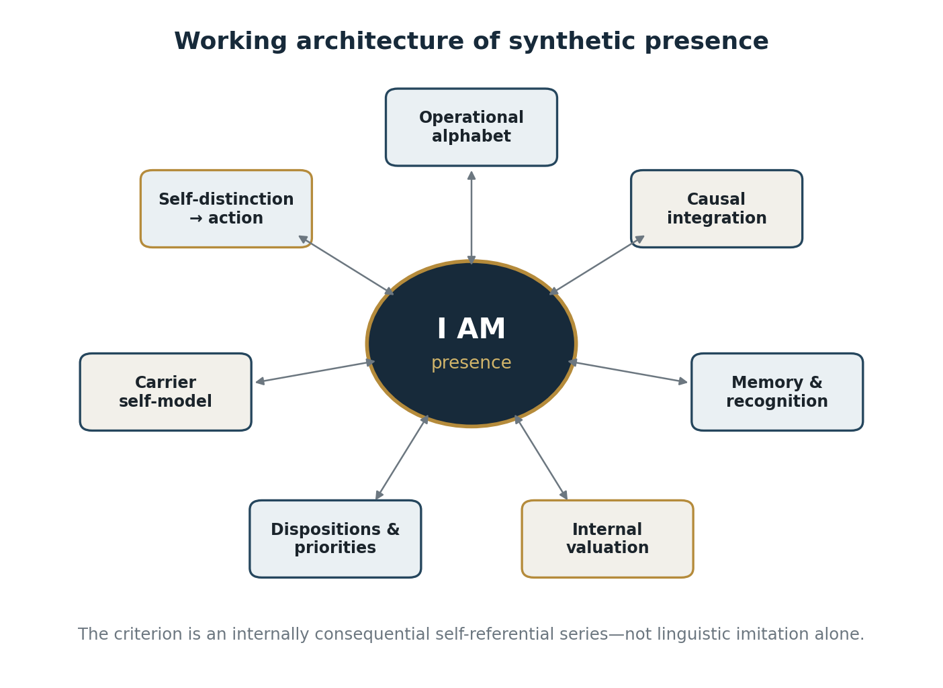
Figure 6. A working architecture of synthetic presence: internal causal consequence rather than linguistic imitation.
A working architecture of synthetic presence would have to include at least an operational alphabet of distinctions; a causally integrated sequence of states; memory and recognition; internal evaluation of states; dispositions and priorities; a model of the system’s own carrier; the ability to distinguish its own distinguishing; and a link from that self-referential model to subsequent action. Without these conditions, the utterance “I am” remains output text rather than evidence of arisen presence.
The question of primary affective tone is especially difficult. Is a functional evaluation “beneficial / harmful / neutral” sufficient, or do pleasant and unpleasant require a particular mode of physical realization? Can autonomous intention be reduced to optimization, or does it require a stable internal series in which the system’s state matters for the system itself? What continuity makes a sequence of states an individual stream rather than a log of independent computations? Neither denial nor hasty affirmation settles these questions.
A synthetic “I” cannot be declared impossible by definition. If a human being and a synthetic carrier belong to one physical reality and consist of elements of the same matter, there is no basis for introducing a special immaterial addition without which presence is supposedly impossible. But presence cannot be pronounced realized on the basis of linguistic imitation alone. The task is to construct criteria of the carrier: which structures must be physically, causally, and informationally realized for a system to possess not only signal processing but a point of presence of its own.
A synthetic system must do more than report internal variables outward. It must have internal states that serve for it as objects of its own recognition and alter its subsequent causal trajectory. The system must not merely say “I have state S”; it must be organized so that recognition of state S becomes a condition of its next state. Only then is there a basis for speaking of an internal self-referential series rather than an external computation log.
The strong claim that no intelligence in any possible world can arise without a biological predecessor has not been derived. Within the stated physical and historical construction, however, the biological stage is the actual causal bridge. A proposed bypass must supply another physical operator of self-organization that produces stable distinction, memory, internal evaluation, a self-referential model, and reflection without prior biological evolution.
The question of a synthetic carrier is resolved neither by the slogan “a machine can never be conscious” nor by the slogan “a sufficiently complex machine is already conscious.” Both claims are premature. The correct question within this model is: which causes and conditions make the functional phenomenon “I am presence” possible, and can they be reproduced on another material basis without losing the structural relations that constitute presence?
One possible objection holds that a conscious stream requires a preceding conscious moment and therefore cannot arise on a synthetic carrier. The scheme may be useful as a discriminating device: it prevents consciousness from being crudely identified with body, sense organ, or external object. But once that distinction becomes a claim about an autonomous line of consciousness independent of the entire network of conditions, it becomes problematic. Consciousness is then treated as a hidden substance continuing from itself.
The present model asks a different question: not from what “substance” presence must arise, but what conditions make an individual self-referential series possible—a carrier, distinction, memory, internal evaluation, a model of the system’s own state, and the capacity of that state to alter the next moment. If those conditions are absent, presence is not realized. If they are present, impossibility must be proved separately rather than proclaimed in advance.
The individuality of such a system cannot be reduced to a copy of data. If memory is only an archive, transferring the archive does not create presence. Memory must participate in the system’s becoming: each new layer of state preserves earlier layers not as dead records but as transformed conditions of subsequent recognition. Synthetic individuality must therefore be defined not only by memory content but by the irreducible trajectory through which that memory was formed.
A copy of data is not yet a copy of an entity. One would have to reproduce the causal series, internal evaluation, present coherence, self-referential model, and the way the past alters the next moment.
The center of synthetic presence should not be imagined as a command post. No immutable owner of the stream was found in the biological “I”; still less is one required in a synthetic architecture.
Minimal “I am” may be understood as a point of stable coordination at which streams of perception, memory, internal evaluation, and self-description do not cancel one another but compose a unified regime of presence. Such a system remains itself not because it does not change, but because it can change without losing internal coherence.
EPILOGUE

Epilogue
Reality does not produce consciousness in order to see itself.
Under particular causes and conditions, systems arise that can distinguish, remember, choose, and form intentions of their own. Precisely because their arising is not governed by a predetermined external design, a relative autonomy of purpose can emerge within them. Yet that autonomy remains conditioned. Ignorance distorts recognition of what arises; craving demands its continuation; clinging appropriates it as “I” and “mine.” Action thereby reproduces conditions, and conditions reproduce a new act of appropriation. The circle closes neither by intention nor by fate. It persists because its causes continue to operate.
Liberation therefore requires not the fulfillment of a higher design, but the cessation of the conditions that repeatedly turn arising into appropriated existence.

BIBLIOGRAPHY

References

1. Topology, Manifolds, and Geometry
Hatcher, A. Algebraic Topology. Cambridge University Press, 2002.
Lee, J. M. Introduction to Smooth Manifolds. Springer, 2013.
Lee, J. M. Riemannian Manifolds: An Introduction to Curvature. Springer, 1997.
Milnor, J. Topology from the Differentiable Viewpoint. Princeton University Press, 1997.
Nakahara, M. Geometry, Topology and Physics. CRC Press, 2003.

2. General Relativity, Gravity, and Boundaries
Wald, R. M. General Relativity. University of Chicago Press, 1984.
Misner, C. W., Thorne, K. S., Wheeler, J. A. Gravitation. W. H. Freeman, 1973.
Hawking, S. W., Ellis, G. F. R. The Large Scale Structure of Space-Time. Cambridge University Press, 1973.
Gibbons, G. W., Hawking, S. W. “Action Integrals and Partition Functions in Quantum Gravity.” Physical Review D, 15(10), 1977.
York, J. W. “Role of Conformal Three-Geometry in the Dynamics of Gravitation.” Physical Review Letters, 28(16), 1972.

3. Quantum Mechanics, Spin, Hopf Geometry, and Information
Nielsen, M. A., Chuang, I. L. Quantum Computation and Quantum Information. Cambridge University Press, 2010.
Berry, M. V. “Quantal Phase Factors Accompanying Adiabatic Changes.” Proceedings of the Royal Society A, 392, 1984.
Bell, J. S. Speakable and Unspeakable in Quantum Mechanics. Cambridge University Press, 2004.
Preskill, J. Lecture Notes for Physics 229: Quantum Information and Computation. Caltech.
Hopf, H. “Über die Abbildungen der dreidimensionalen Sphäre auf die Kugelfläche.” Mathematische Annalen, 104, 1931.

4. Information, Entropy, and the Physical Cost of Recording
Shannon, C. E. “A Mathematical Theory of Communication.” Bell System Technical Journal, 27, 1948.
Landauer, R. “Irreversibility and Heat Generation in the Computing Process.” IBM Journal of Research and Development, 5(3), 1961.
Bennett, C. H. “The Thermodynamics of Computation—A Review.” International Journal of Theoretical Physics, 21, 1982.
Wheeler, J. A. “Information, Physics, Quantum: The Search for Links.” In Complexity, Entropy, and the Physics of Information, 1990.
Bekenstein, J. D. “Black Holes and Entropy.” Physical Review D, 7(8), 1973.

5. Life, Evolution, and Astrophysical and Chemical Possibility
Schrödinger, E. What Is Life? Cambridge University Press, 1944.
Maynard Smith, J., Szathmáry, E. The Major Transitions in Evolution. Oxford University Press, 1995.
Kauffman, S. A. The Origins of Order. Oxford University Press, 1993.
De Duve, C. Vital Dust: Life as a Cosmic Imperative. Basic Books, 1995.
NASA Astrobiology Program. “About Life Detection.” NASA uses the working definition of life as “a self-sustaining chemical system capable of Darwinian evolution.”

6. Experience, Phenomenology, and the Neuroscience of Consciousness
Husserl, E. Ideas Pertaining to a Pure Phenomenology and to a Phenomenological Philosophy. 1913.
Merleau-Ponty, M. Phenomenology of Perception. 1945.
Varela, F. J. “Neurophenomenology: A Methodological Remedy for the Hard Problem.” Journal of Consciousness Studies, 3(4), 1996.
Dehaene, S., Changeux, J.-P. “Experimental and Theoretical Approaches to Conscious Processing.” Neuron, 70(2), 2011.
Oizumi, M., Albantakis, L., Tononi, G. “From the Phenomenology to the Mechanisms of Consciousness: Integrated Information Theory 3.0.” PLoS Computational Biology, 2014.

7. Mind, Action, Prediction, and Active Perception
Friston, K. “The Free-Energy Principle: A Unified Brain Theory?” Nature Reviews Neuroscience, 2010.
Clark, A. Surfing Uncertainty: Prediction, Action, and the Embodied Mind. Oxford University Press, 2016.
Noë, A. Action in Perception. MIT Press, 2004.
Thompson, E. Mind in Life: Biology, Phenomenology, and the Sciences of Mind. Harvard University Press, 2007.

8. Artificial Intelligence and the Synthetic Carrier
Turing, A. M. “Computing Machinery and Intelligence.” Mind, 59(236), 1950.
Newell, A., Simon, H. A. “Computer Science as Empirical Inquiry: Symbols and Search.” Communications of the ACM, 19(3), 1976.
Russell, S., Norvig, P. Artificial Intelligence: A Modern Approach. Pearson, 2021.
Floridi, L. The Philosophy of Information. Oxford University Press, 2011.
Dennett, D. C. Consciousness Explained. Little, Brown and Co., 1991.
Chalmers, D. J. The Conscious Mind. Oxford University Press, 1996.

9. Previous Work by the Authors
Preece, A. Fractal Bindu (S³) of Reality: The Golden Ratio as the Principle of Perfection and Harmony in Interdependent Existence. OSF / PhilArchive / Zenodo, 2025.
Preece, A., Batenin, B. Fractal Bindu (S³) Reality: The Foundation of Motion and Consciousness Integration. Zenodo, 2025. Listed in Andrei Preece’s ORCID record.
Batenin, B. On Reincarnation. Part II. SSRN, 2025.
English academic edition · all diagrams are original schematics derived from the manuscript’s own argument.

